Gymnodinium F. Stein 1878
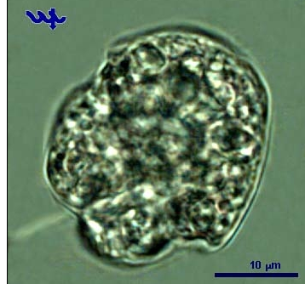

Phylum: Dinoflagellata
Class: Dinophyceae
Order: Gymnodiniales

Habitat: plankton
Organization: flagellated single cells
Color: yellow to golden-brown
Cell shape: mushroom-like, close to a sphere
Cell diameter (D): 7.6 – 12.3 μm, median: 9.7 μm (N=587).
Cell diameter varies significantly over time, making it necessary to measure it routinely.
Cell biovolume: 230 - 1000 μm³, median: 470 μm³.
Biovolume equation: sphere, V = 4/3 π (D/2)³. A prolate spheroid is probably the more suitable shape for this species but we have simplified our routine cell-size measurements and considered it a sphere.

Morphological features:
Gymnodinium is a classic naked dinoflagellate, the genus includes both photosynthetic and heterotrophic species. The cingulum bisects the cell into two halves, or cones, of somewhat different shapes, the lower or hypocone is a half-sphere, the top or epicone is a bit larger and more conical. With those two cones placed one on top of the other, the cell often looks like a mushroom (Plate 1). Gymnodinium has two unequal flagella, the longitudinal whiplash flagellum extending from the bottom side of the mushroom is seen in Plate 1, the second, transverse flagellum is hidden in the cingulum.

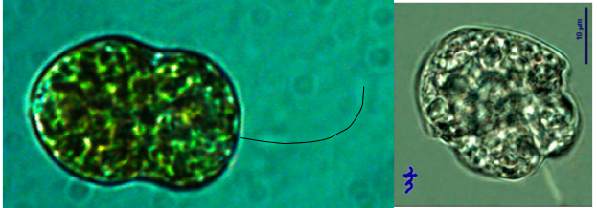
Plate 1: Gymnodinium, showing the overall mushroom shape of half sphere covered by a cone, the cingulum region, and the whip flagellum. Photos: Alla Alster.
Ecology:
Several species of naked dinoflagellates of the genera Gymnodinium and Glenodinium occur in Lake Kinneret, they were never identified to species level. Of those, a small species of Gymnodinium (cell volume ~ 500 μm³) is most common. The data presented here are for this small Gymnodinium sp. Gymnodinium never forms blooms but occurs quite often at low cell densities, usually < 50 cells/mL, contributing to total phytoplankton biomass up to a maximum of ~3 g m⁻² (Fig. 1). It can appear in the plankton at all times of the year but is more abundant during stratification, from May to December, with highest cell abundances occur in June-July (Fig. 2). Cell size fluctuates seasonally, with largest cell-size in summer (Fig. 2). This is different from the cell size of other Kinneret dinoflagellates, that is usually largest in winter. The reason could be that more than a single species has been counted as Gymnodinium, with a larger species more common in summer.
Higher cell abundances are associated with water temperatures > 23°C (Fig. 3). Gymnodinium occurs over the full range of conductivity, Cl, Ca, alkalinity, SO₄, Si, water levels and solar radiation levels recorded in the lake, mostly when transparency is high (at lower ambient concentrations of chlorophyll a, and when euphotic zone depth is around 10 m. It is more abundant when ammonium and nitrate are low (Fig. 3), but DON is abundant (not shown), suggesting potential heterotrophic nutrition in addition to photosynthesis by a mixotroph.
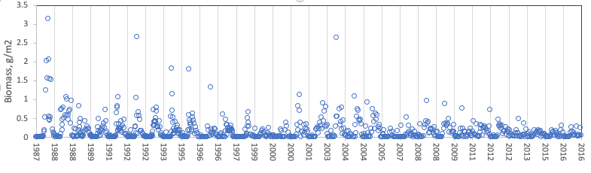
Figure 1. Time series of Gymnodinium sp. depth-integrated wet-weight biomass (g m⁻²), Lake Kinneret, 1987-2016.
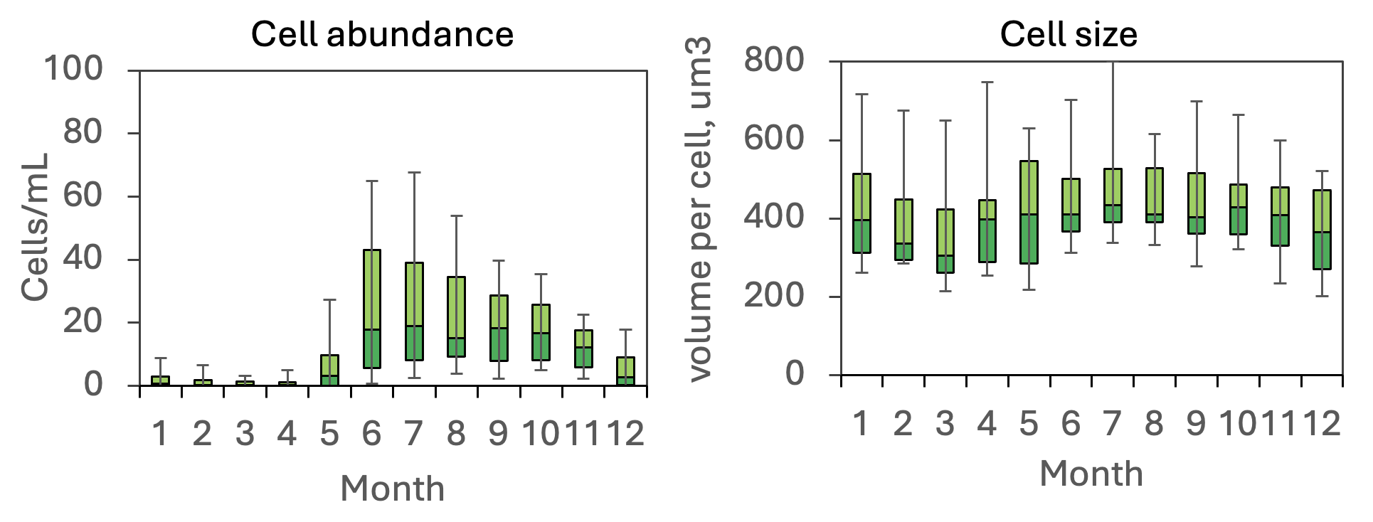
Figure 2. Annual patterns of water column cell abundance and cell size (as volume per cell) of Gymnodinium spp. showing its higher abundances in the second half of the year (left) and a typical sinusoidal pattern of cell size (right). Data are from 2006-2020.
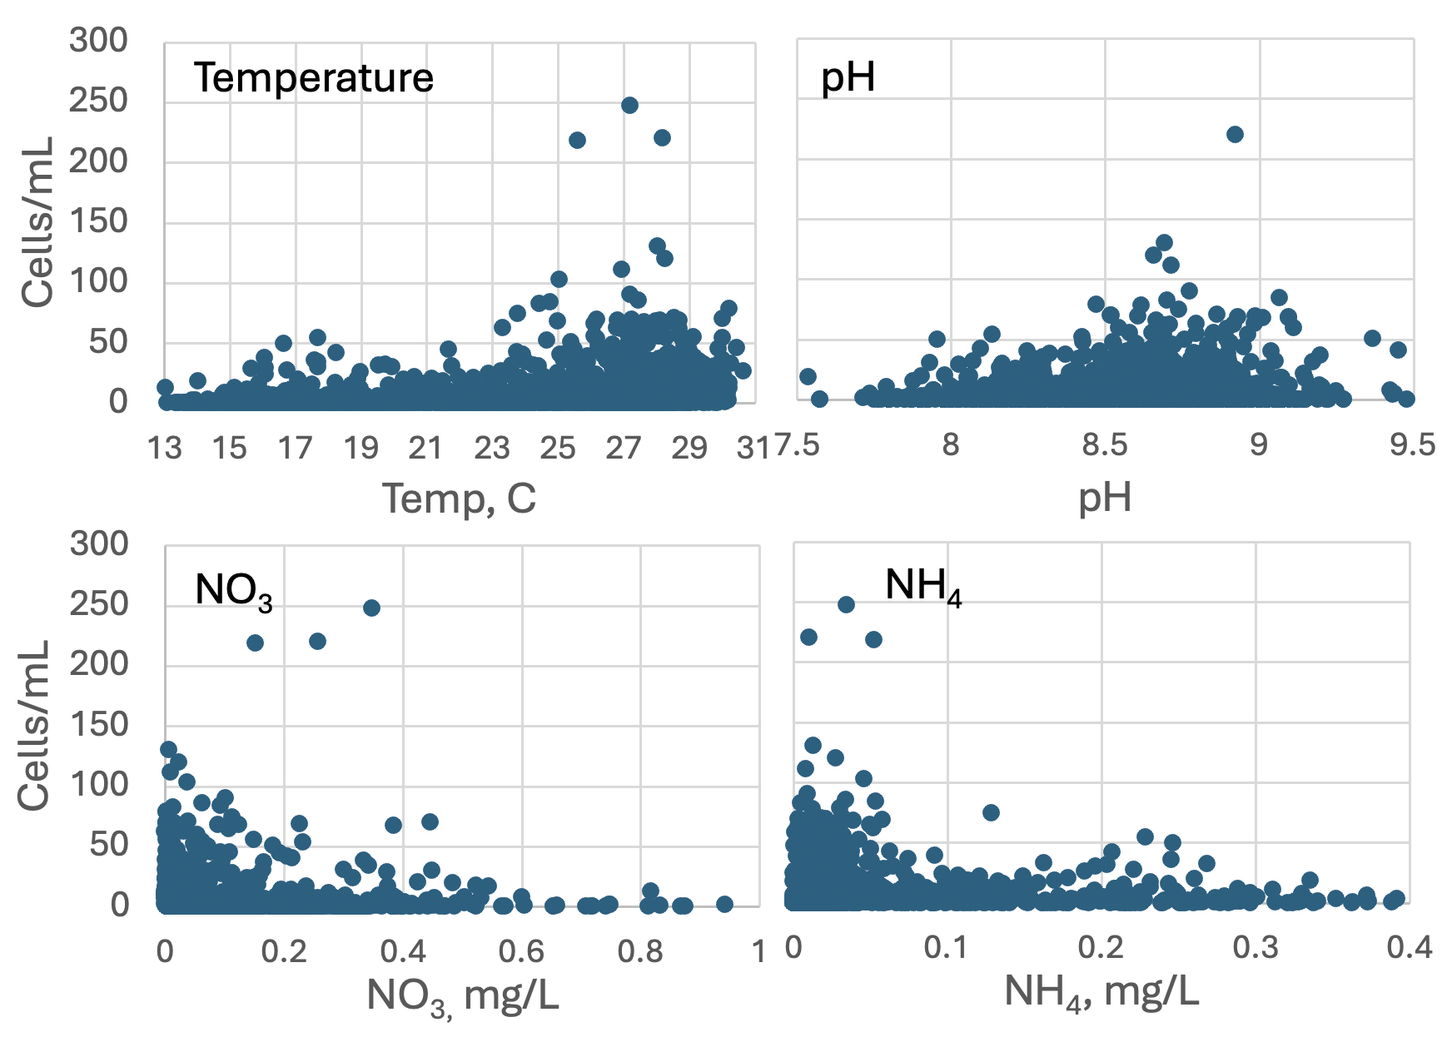
Figure 3. Gymnodinium abundance (cells mL⁻¹) vs. environmental parameters recorded at the site and time of sampling, showing tendency for higher cell concentrations at temperatures > 23°C, pH > 8.4, and lower concentrations of NO₃ and NH₄. Field data from 1987-2020.
Cite this record as: Tamar Zohary, Alla Alster. 16 April 2026. Electronic publication. Israel Oceanographic & Limnological Research. [Date when last accessed].
Ceratium furcoides (Levander) Langhans 1925
Previous name used: Ceratium hirunidnella var. furcoides Dujardin
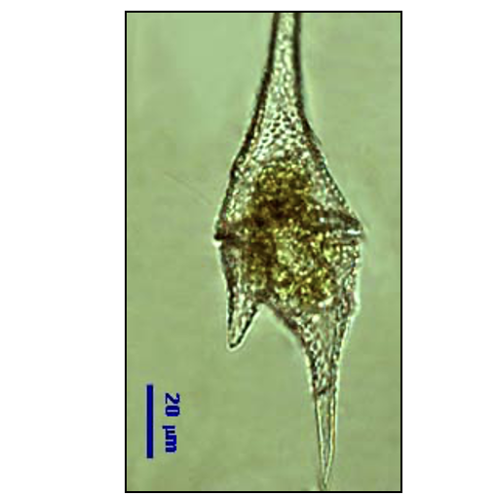
Phylum: Dinoflagellata
Class: Dinophyceae
Order: Gonyaulacales

Habitat: plankton
Organization: flagellated single cells
Color: yellow to golden-brown
Cell shape: a spheroid from which 2-4 horns of different lengths extend
Cell diameter: 30-50 μm wide
Cell length: 165-260 μm long (literature values)
Cell biovolume: 70,000 μm³ (literature value, we do not routinely measure this species)

Morphological features: The genus Ceratium has a distinct shape of a central body from which several horns extend to opposite directions (Plate 1), this shape can’t be mistaken with any other genus occurring in Lake Kinneret. Cells of C. furcoides are slender, longer than wide, strongly dorsiventrally flattened. Epitheca gradually tapers into a long apical horn without shoulders. Hypotheca broad and short, drawn out into 2 (occasionally 1 or 3) posterior horns of different lengths. Nucleus prominent in epicone. Cysts are smooth-walled, triangular, with one narrow horn extending from each corner. Ceratium furcoides is narrower and slenderer than the more common C. hirundinella.
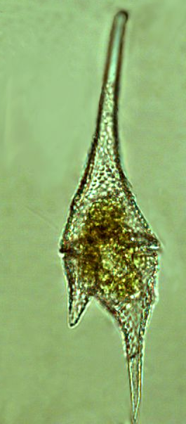
Plate 1. Ceratium furcoides. Photo: Alla Alster.

Ecology:
Historically this species was identified as Ceratium hirundinella var. furcoides and counted as C. hirundinella. Therefore, there are no ecological data specific for it.
Cite this record as:
Tamar Zohary, Alla Alster. 16 April 2026. Electronic publication. Israel Oceanographic & Limnological Research. [Date when last accessed].

Further reading:
Hansen G, Flaim G. 2007. Dinoflagellates of the Trentino province, Italy. Journal of Limnology 66(2):107-41.

Hickel B. 1988. Sexual reproduction and life cycle of Ceratium furcoides (Dinophyceae) in situ in the lake Plußsee (FR). Hydrobiologia 161(1): 41-48.
Ceratium hirundinella (O.F. Muller) Dujardin 1841
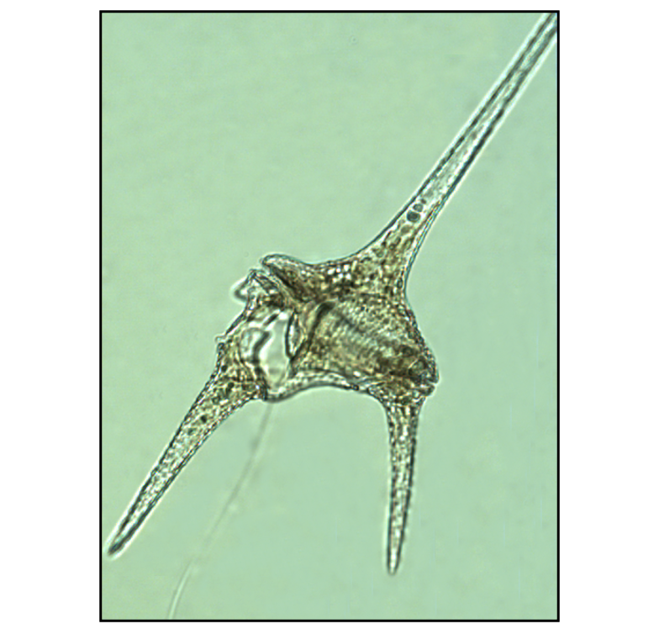

Phylum: Dinoflagellata
Class: Dinophyceae
Order: Gonyaulacales

Habitat: plankton
Distinctive attributes: Too large to be grazed by Kinneret zooplankton. Nutrirtion is autotrophic and holozoic by means of pseudopodia.
Organization: flagellated single cells
Color: yellow to golden-brown
Cell shape: a spheroid from which 2 to 5 (usually 3 or 4) horns of different lengths extend
Cell diameter (D): 45-63 μm (literature values)
Cell length (L): 155-200 μm (literature values)
Cell Biovolume: 73,000 μm³ (literature value, we do not routinely measure this species)

Morphological features: The genus Ceratium has a distinct shape of a central body from which several horns extend to opposite directions, making the cell longer than wide (Plate 1), this shape can’t be mistaken with any other genus occurring in Lake Kinneret. In C. hirundinella, all or part of the horns are usually colorless, the gold-pigmented protoplast (living part of the cell) is concentrated in the cell’s center. Small red bodies are often present. The helmet shaped epitheca narrows from just above the cingulum gradually forming a long horn. The cingulum is slightly narrow. The body of the hypotheca is broad and short. It is divided into a varying number of posterior horns, usually 3, sometimes only 1. The central or median horn formed by the antapical plates is the longest. Chloroplasts are numerous and oval shaped. Occasionally, the longitudinal flagellum can be observed microscopically (Plate 1a). Resting cysts of C. hirundinella are triangular with one horn on each end (Plate 1c).
Several morphotypes of this species occur in Lake Kinneret, the most common is var. robustum Bachman, shaped like the Eifel Tower (Plate 1a,b). Other forms found in L Kinneret are forma gracile, type scoticum and the variety furcoides, now allocated to a separate species, C. furcoides.

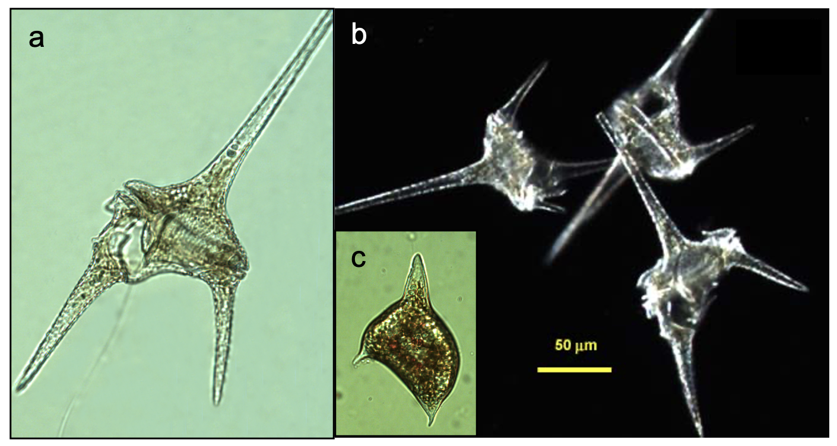
Plate 1. Ceratium hirundinella in Lake Kinneret. (a) light-field photo, showing distinct cingulum, horns and a flagellum; (b) dark-field photo, showing Eifel Tower shape; (c) cyst with red bodies and 3 horns. Photos: Alla Alster.
Ecology:
C. hirundinella is the largest single-celled species occurring in the plankton of Lake Kinneret. It is one of the common dinoflagellate species, although usually it appears in low abundance, with mean epilimnetic concentrations of < 10 cells mL⁻¹ (Fig. 1), and <10% contribution to total biomass. An exception was a spring bloom in 2010, a year when Peridinium gatunense didn’t bloom. Cell concentration in the epilimnion reached 50 cells mL-¹ on14 March 2010, with biomass of 150 g m⁻² (Fig. 1), contributing > 70% to total biomass.
This species appears in the water column in January, peaks between March and June, then disappear from the water till next spring (Fig. 2). The mean abundance of C. hirundinella has increased since the mid 1990s and tends to be higher in years with no or moderate intensity Peridinium gatunense blooms.
Vegetative and sexual reproduction is known.
Ceratium cysts commonly appear in the Kinneret plankton in March and April (Fig. 2). They are more numerous than cysts of Peridinium gatunense even though the abundance of Ceratium vegetative cells is an order of magnitude lower than that of Peridinium.

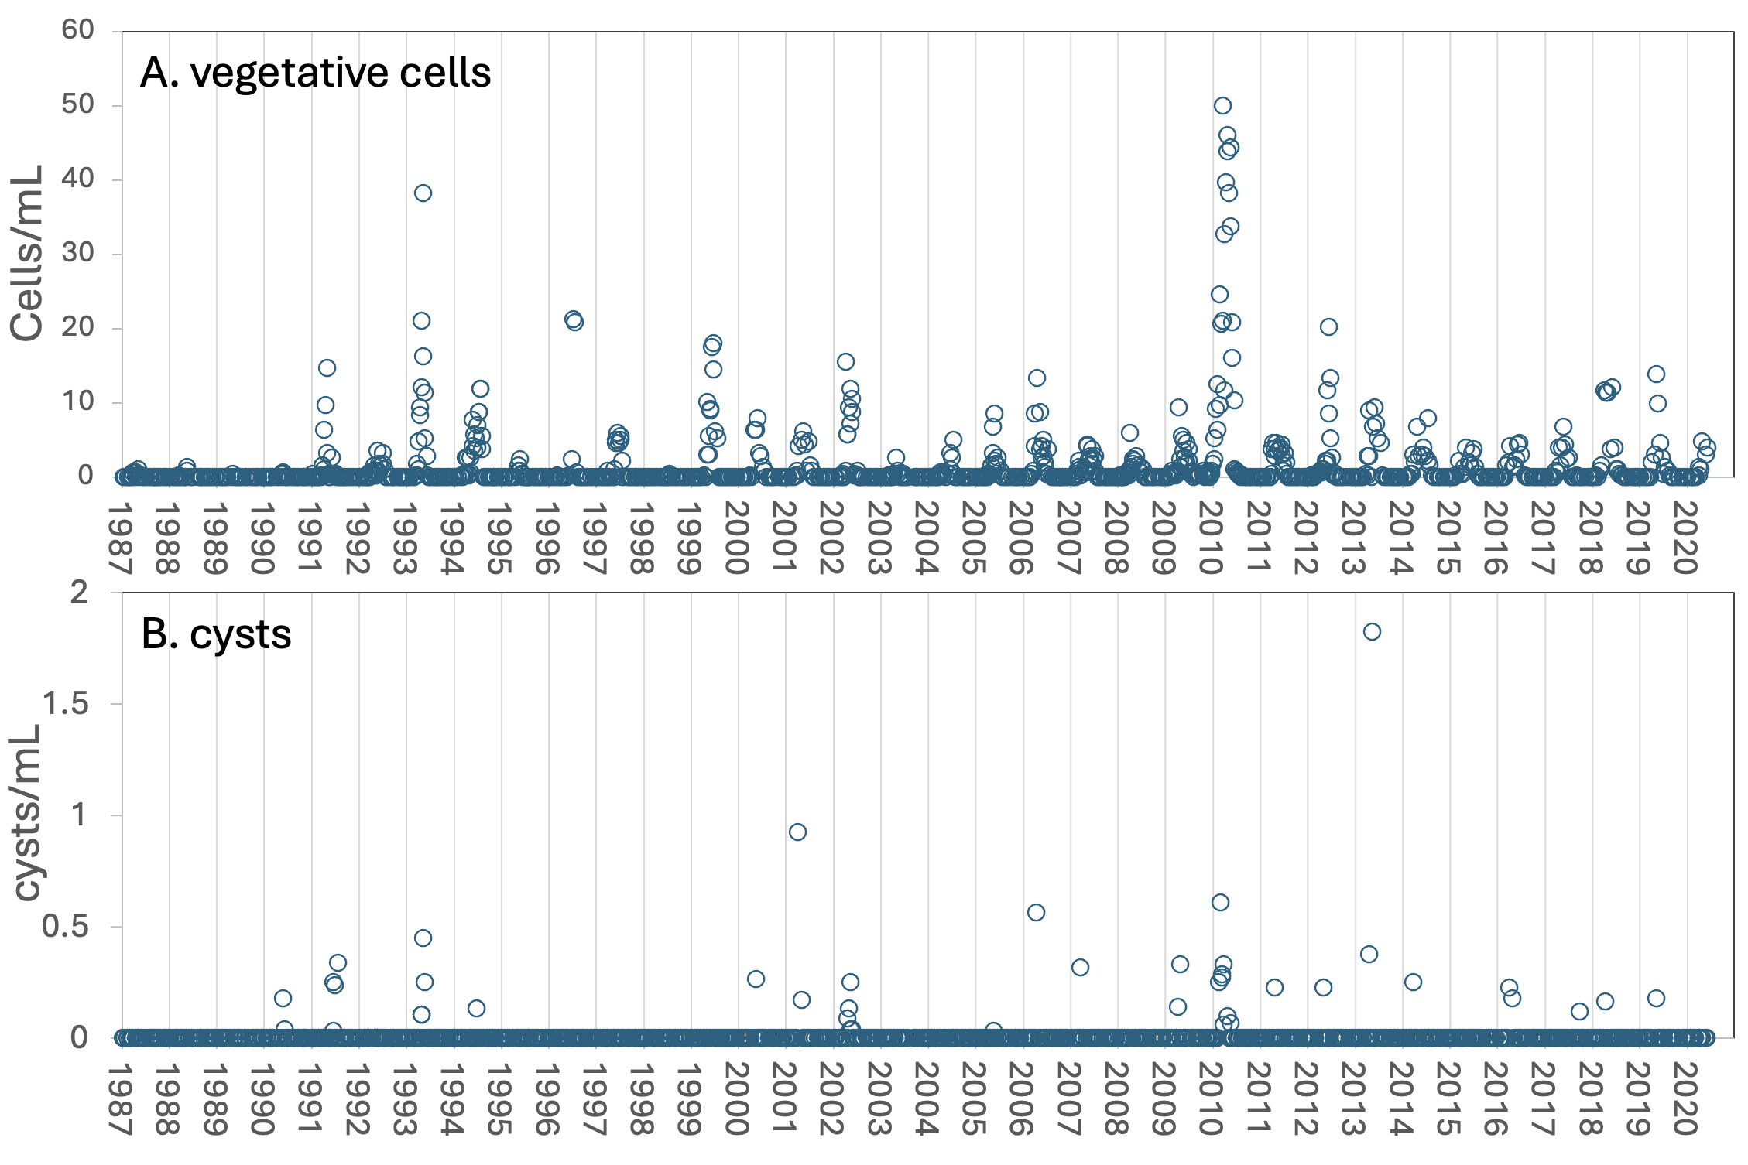
Figure 1. Time series of the mean epilimnion abundance of vegetative cells (A) and cysts (B) of Ceratium hirundinella in Lake Kinneret, 1987-2020.
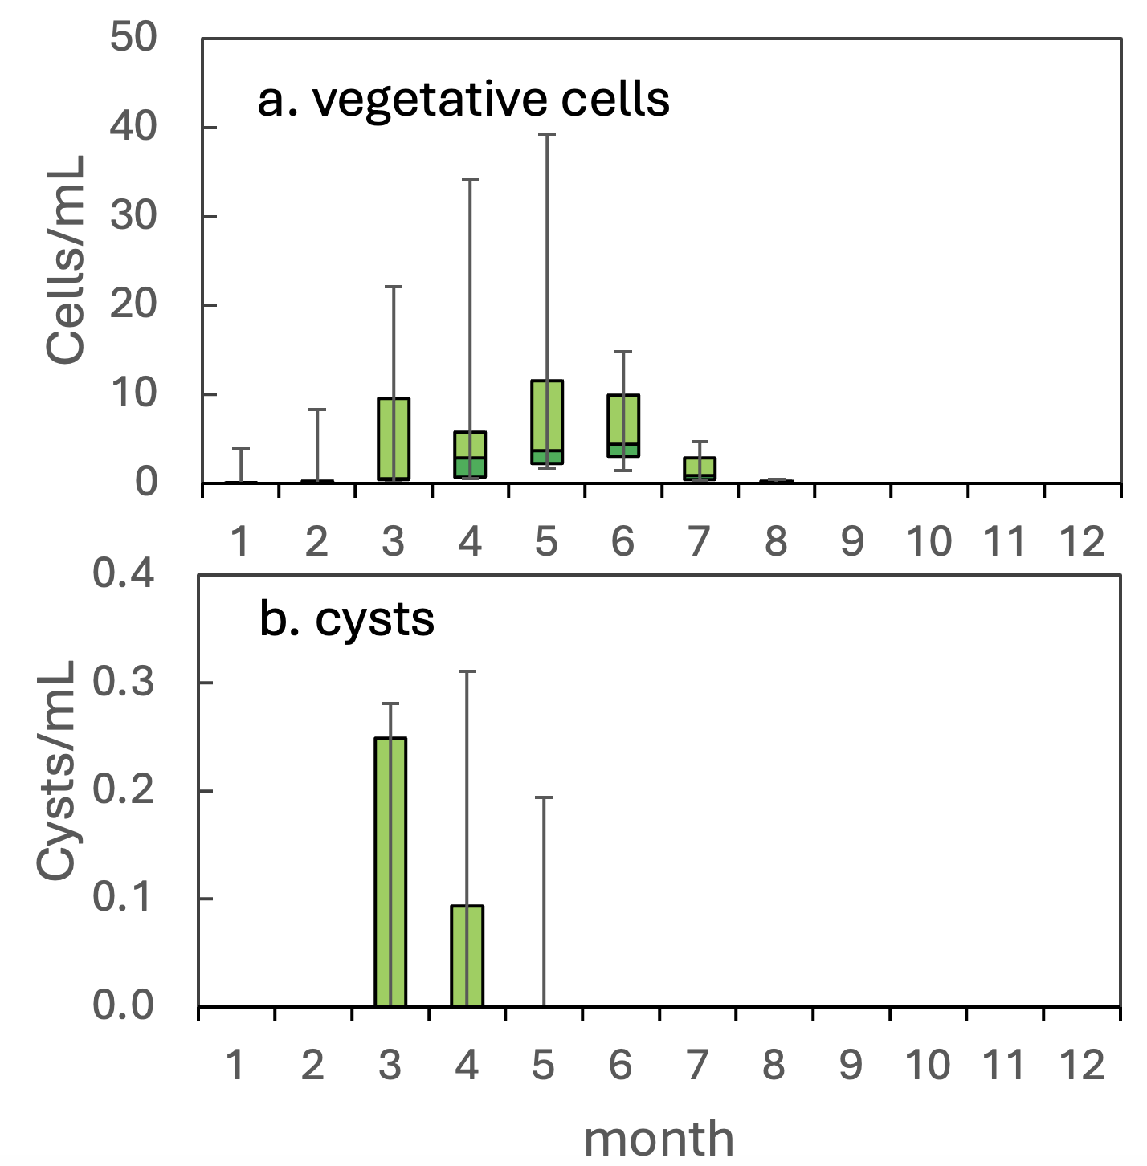
Figure 2. Ceratium hirundinella – The seasonal pattern of cell abundance for vegetative cells and for cysts.
Environmental conditions: Over the years, higher cell abundances of C. hirundinella (> 5 cells mL⁻¹) occurred usually during thermal stratification, over the full ranges of salinities and Ca concentrations, at water temperatures ranging 16-29°C, intermediate alkalinities (90-140 mg CaCO₃ L⁻¹), and distinctly at pH > 8.5, when both nitrate and organic N (particulate and dissolved) are present (Fig. 3).
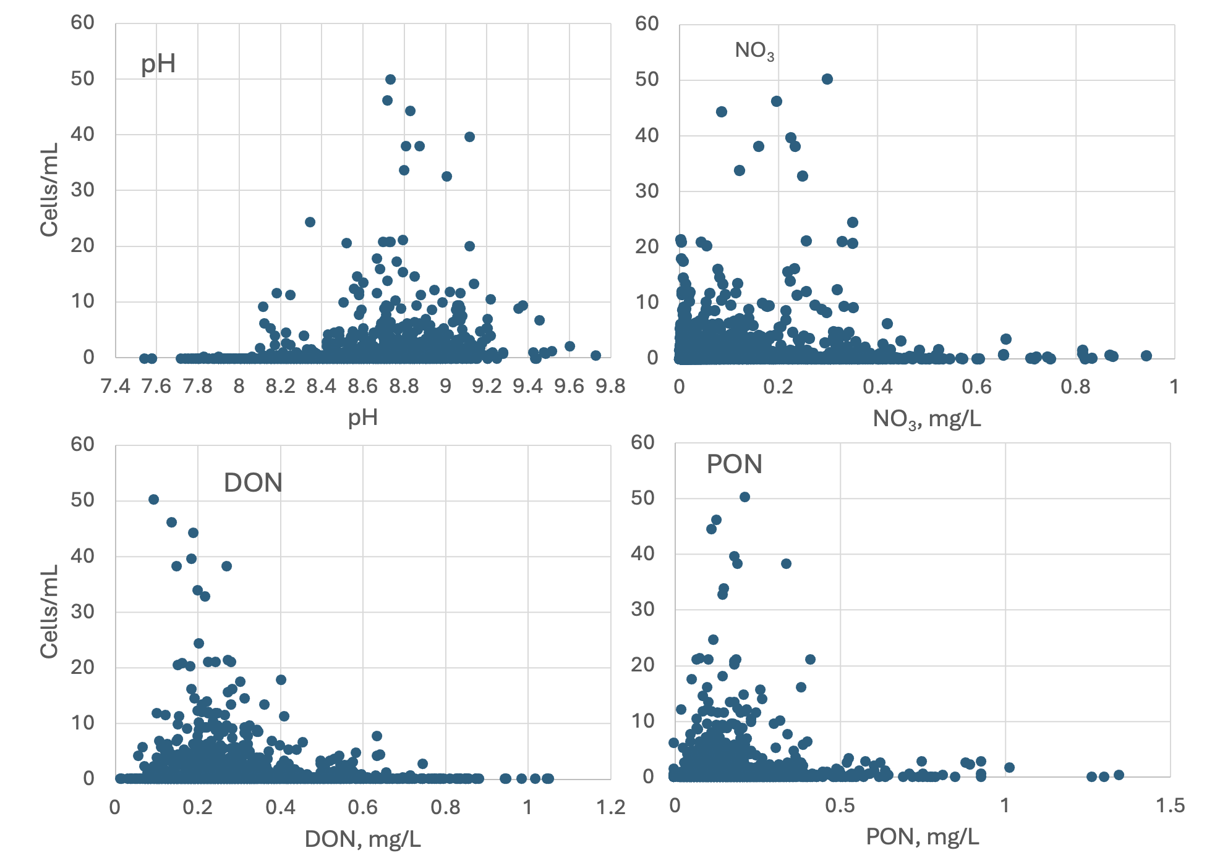
Figure 3. Cell abundance of Ceratium hirundinella as a function of selected environmental variables, based on data from 1987-2020.
Cite this record as:
Tamar Zohary, Alla Alster. 16 April 2026. Electronic publication. Israel Oceanographic & Limnological Research. [Date when last accessed].
Further reading:
Pollingher U, Hickel B. 1991. Dinoflagellate associations in a subtropical lake (Lake Kinneret, Israel). Arch Hydrobiol 120:267-285
Hansen G, Flaim G. 2007. Dinoflagellates of the Trentino province, Italy. Journal of Limnology. 66(2):107-41.

Diplopsalis acuta (Apstein) Entz 1906
Previous name used: Entzia acuta (Apstein) Lebour 1922
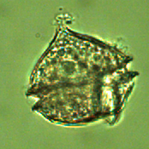

Phylum: Dinoflagellata
Class: Dinophyceae
Order: Peridiniales
Habitat: plankton, littoral (more abundant) and pelagial,
Distinctive attributes: the only non-pigmented thecate dinoflagellate of Lake Kinneret.
Organization: flagellated single cells
Color: pinkish, non-pigmented (heterotrophic)
Cell shape: flat cone (Chinese hat) on top of a half-sphere (Plate 1).
Cell Diameter (D): 34 - 47 μm, median: 38 μm (N=92)
Cell Length (L): 17 – 23 μm, median: 19 μm (N=92)
Cell biovolume: 15,000 – 40,000 μm³, median: 22,000 μm³.
Biovolume equation: V, μm³ = (π/12) *D² *(D+h) (= volume of half sphere+cone, see Hillebrand et al. 1999).

Morphological features:
Diplopsalis acuta is the only known heterotrophic (non-pigmented) thecate dinoflagellate in the lake’s pelagic waters. Its shape is distinct, of a half sphere with a Chinese hat on top of it (Plate 1). Another feature differentiating it from other Kinneret dinoflagellates is that its diameter at the cingulum is greater than its height. Its thecae are thick and distinct. Chloroplasts and stigma are lacking (heterotrophic). The protoplast is pink. The hypotheca is broadly rounded and slightly flattened dorsiventrally. Plates are not sculptured and have no reticulations.
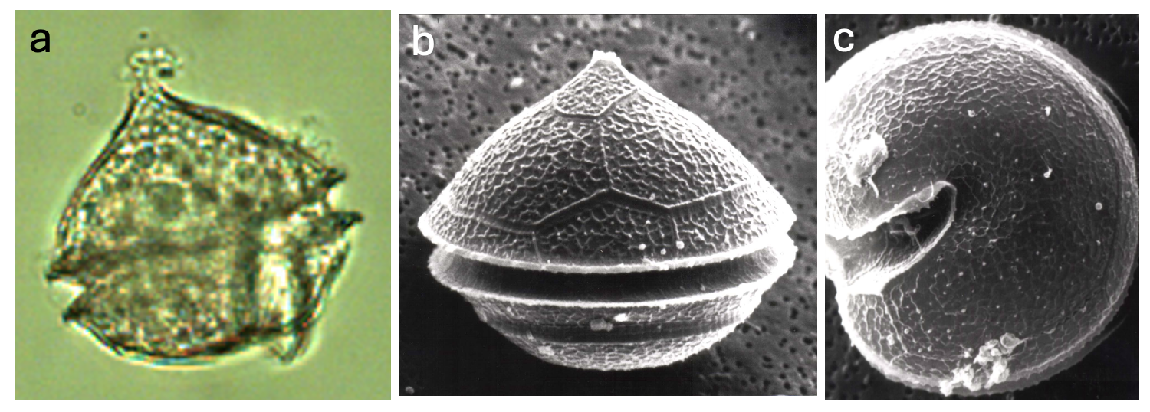
Plate 1. Diplopsalis acuta from Lake Kinneret. (a) light microscope photo showing the cingulum, and a flagellum. (b, c): SEM photos of side view (b) and hypotheca (c). SEM photos: Barbara Hickel. Light microscope photo: Alla Alster.
Ecology: Diplopsalis acuta is one of the regularly occurring dinoflagellates of Lake Kinneret, although it is present in low concentrations, usually < 2 cells mL⁻¹ (Fig. 1). It appears in the plankton from November (onset of destratification) to July, with peak abundance in March (Fig. 2), before the lake stratifies, and earlier than most other Kinneret dinoflagellates. It is more common in littoral samples.
Being heterotrophic, Diplopsalis acuta is excluded from the computation of total phytoplankton biomass in our routine monitoring.

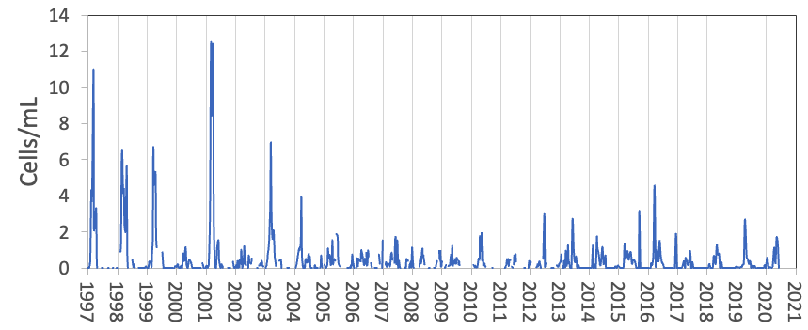
Figure 1. Diplopsalis acuta – time series of cell abundance, 1997-2020.

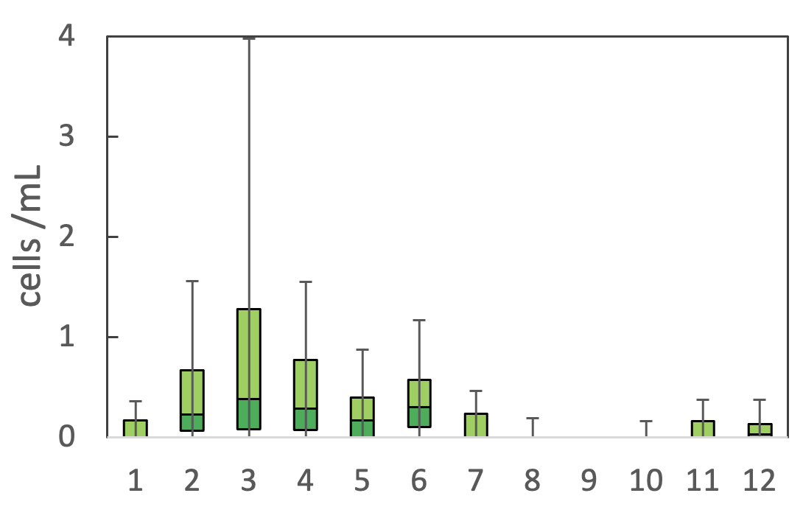
Figure 2. Diplopsalis acuta – the annual cycle of cell abundance, 1974 -2020.
Environmental conditions:
Higher cell abundances of this species occurred at higher Kinneret alkalinity (> 100 mg CaCO₃ L⁻¹), Ca (> 40 mg L⁻¹), TDP, and DO concentrations, when Dissolved organic N (DON) ranged 0.1-0.5 mg L⁻¹ and Secchi depth ranged 2-4 m, At low turbidity (< 4 NTU) waters, and low Si (Fig. 3). Abundance seemed to be indifferent to water level, conductivity, chloride, short wave radiation. Abundance was higher with lower long-wave radiation levels and water temperatures < 25°C, but both may be correlates of the time of year of its peak abundance.
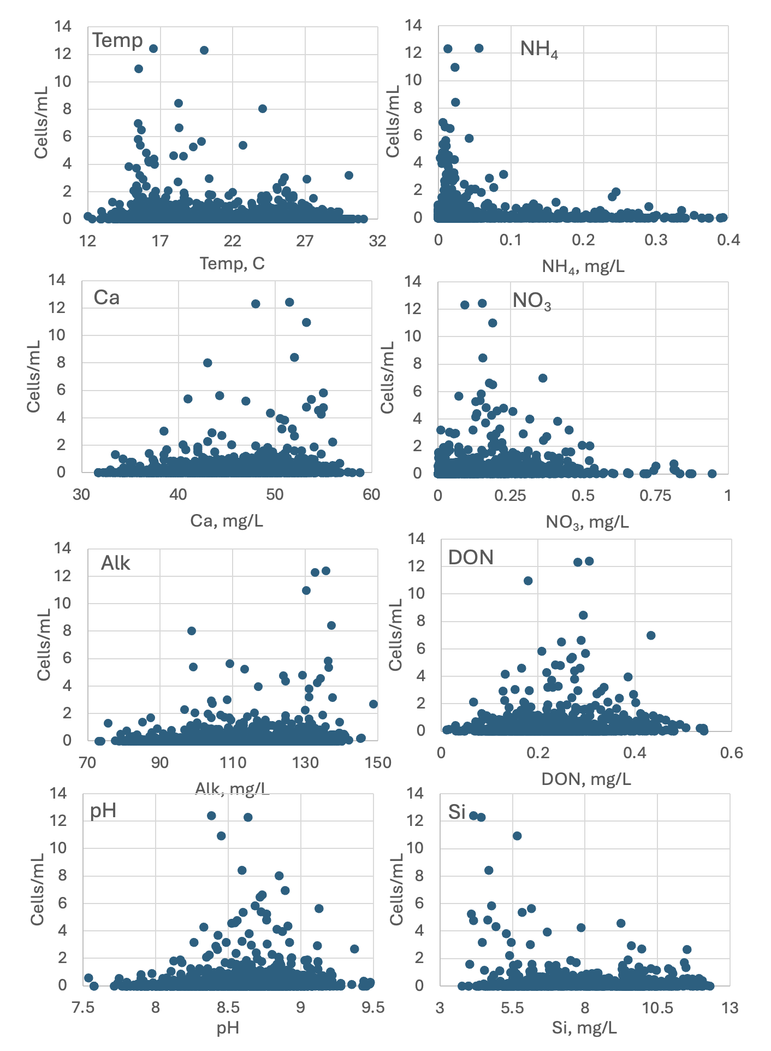
Fig. 3. Diplopsalis acuta abundance (cells mL⁻¹) vs. environmental parameters recorded at the site and time of sampling, showing tendency for higher cell concentrations at higher alkalinity, lower Si and NH₄. Based on field data from 1970-2020.
Cite this record as:
Tamar Zohary, Alla Alster. 16 April 2026. Electronic publication. Israel Oceanographic & Limnological Research. [Date when last accessed].
Further reading:
Moestrup Ø, Calado AJ. 2018. Süßwasserflora von Mitteleuropa. Dinophyceae. Vol. 6 pp. [i]-xii, [1]-560, 421 figures. Berlin: Springer Spektrum.
Pollingher U, Hickel B. 1991. Dinoflagellate associations in a subtropical lake (Lake Kinneret, Israel). Archiv für Hydrobiologie 120(3):267-85.

Peridiniopsis borgei Lemmermann 1904
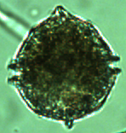
Phylum: Dinoflagellata
Class: Dinophyceae
Order: Peridiniales

Habitat: plankton, pelagial
Distinctive attributes: mixotroph, heavily grazed by zooplankton, capable of using bicarbonate for photosynthesis.
Organization: flagellated single cells
Color: yellow to golden-brown
Cell shape: near-sphere
Cell Diameter (D): 29 – 40.5 μm, median: 34 μm (N=580)
Cell length (L): 32 – 44 μm, median: 39 μm (N=262)
Cell biovolume: 14,000 – 40,500 μm³, median: 21,300 μm³. Larger cell size in winter, smaller in summer (see Fig. 2b).
Biovolume equation: V = 0.9405 D^{2.8596} (regression eqn. based on >500 measurements of both D and L with V computed for a prolate spheroid).

Morphological features: Peridiniopsis borgei is the largest of several species of Peridiniopsis, Durinskia, Glechodinium, Naiadinium, and Parvodinium occurring in the lake. Its shape is almost a sphere (Plate 1), with the cingulum, or girdle, markedly transversing it in the middle. The epitheca is conical with a mouth-like tip at the apex (highest point), the hypotheca is broadly rounded. Sometimes the hypotheca has an extension at its bottom end, like a small “foot”. Chloroplasts are numerous and ribbon shaped.
Diagnostic features seen with electron microscopy: the sulcus slightly extends into the epitheca, it widens in the hypotheca, it does not reach the antapex (Plate 1 d,e). Sulcal margins sometimes have raised edges.
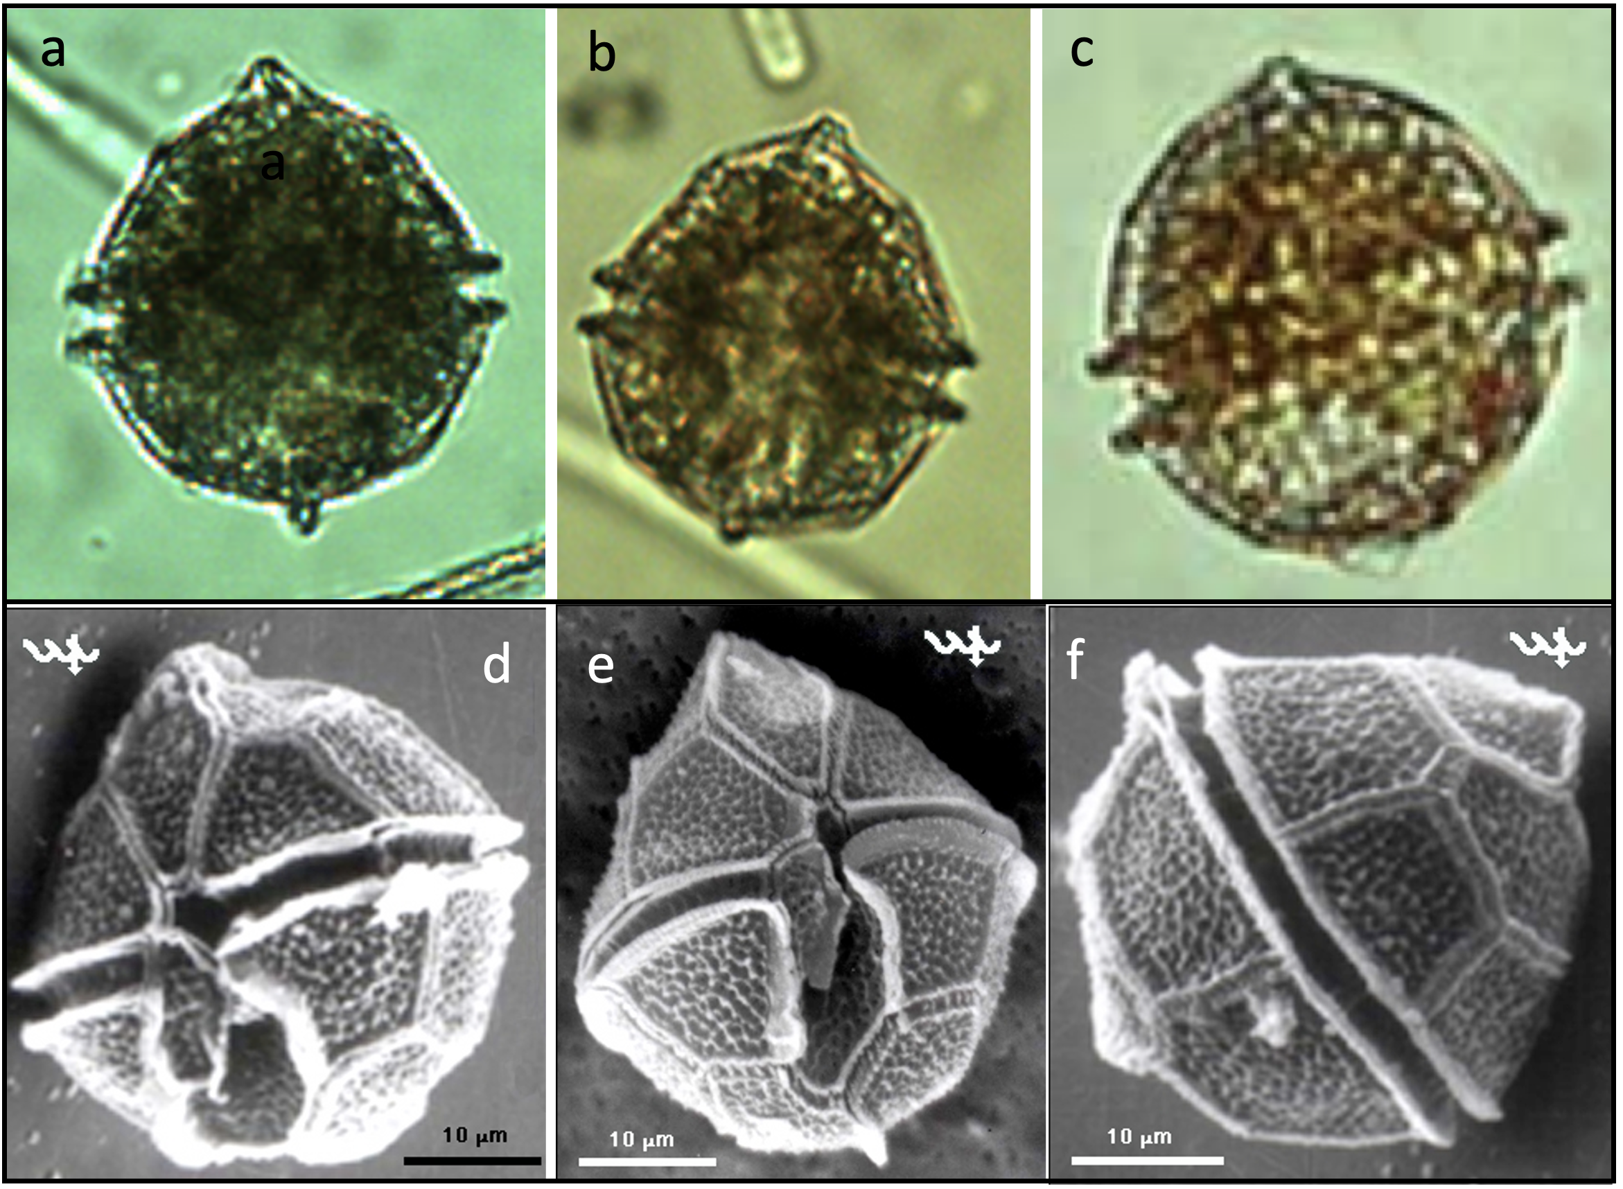
Plate 1. Peridiniopsis borgei. Light microscope (a-c) and SEM photos (d-f) showing the diagnostic features of near-sphere shape, distinct cingulum, single “foot” in some but not all cells, pointed tip at the apex, ventral sulcus extending slightly into the epitheca, mostly into the hypotheca but not reaching the antapex (d, e), and dorsal view (f). Light microscope photos: Alla Alster; SEM photos: Barbara Hickel.
Ecology: Peridiniopsis borgei is one of several subdominant dinoflagellates, common in spring each year (Fig. 1). It reaches peak abundance of several tens of cells per ml in May-June and remains present in the plankton until October (Fig. 2a). The contribution of Peridiniopsis borgei to total biomass was usually < 10% but on rare occasions it reached 40%. Peridiniopsis borgei shows an annual cycle also of cell size (Fig. 2b). Its cellular volume increases during the bloom increase phase, reaching maximum size (diameter: 37 μm, volume: 31,000 μm³) before reaching peak cell abundance, then cell size declines to a minimum (diameter: 27 μm, volume: 11,000 μm³) at about the same time as the minimum cell abundance. Peridiniopsis borgei is potentially capable of using HCO₃ as C source for photosynthesis when pH is high and CO₂ availability low (Berman-Frank et al. 1994). It is an important food source for zooplankton in late spring, after the decline of Peridinium gatunense (Zohary et al. 1994).
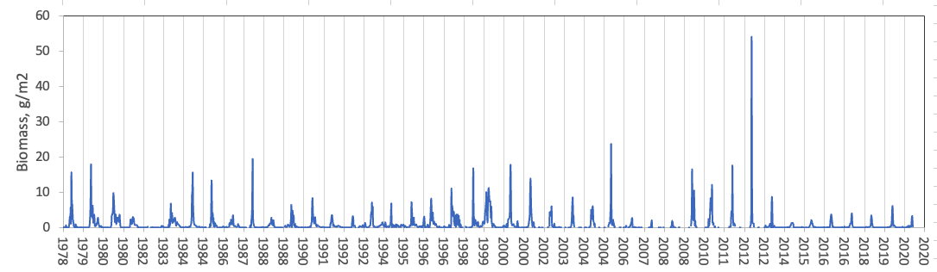
Fig. 1. Time series of Peridiniopsis borgei biomass in Lake Kinneret, 1978-2020.
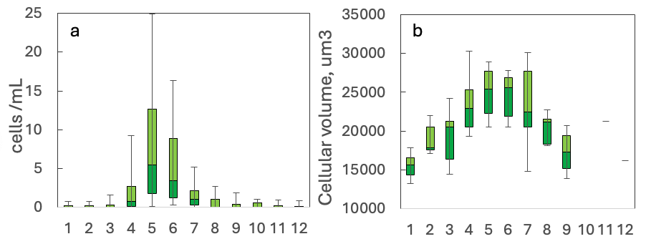
Fig. 2. The annual cycle of Peridiniopsis borgei in Lake Kinneret, 1978-2020: (a) cell abundance, (b) cell size, as volume per cell.
Environmental conditions: Peridiniopsis borgei biomass > 5 g m⁻² occurred more frequently but not exclusively at pH > 8.5, alkalinity < 130 mg L⁻¹, chloride <280 mg L⁻¹, at water temperatures >17°C (Fig. 3), and over the full range of TDP and calcium concentrations, when the lake was stratified (not shown).
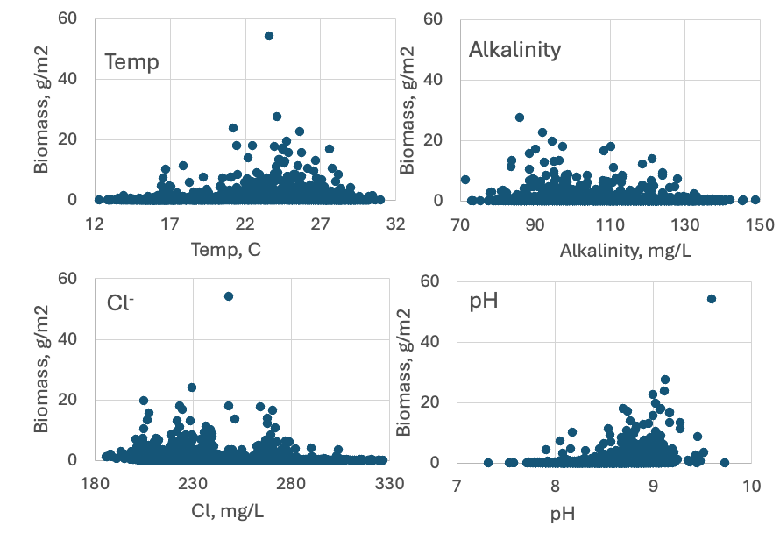
Figure 3. Peridiniopsis borgei biomass vs. selected environmental parameters from Lake Kinneret. Based on data for 1978-2020.
Cite this record as:
Tamar Zohary, Alla Alster. 16 April 2026. Electronic publication. Israel Oceanographic & Limnological Research. [Date when last accessed].
Further reading:
Berman-Frank I, Zohary T, Erez J, Dubinsky Z. 1994. CO₂ availability, carbonic anhydrase, and the annual dinoflagellate bloom in Lake Kinneret. Limnol. Oceanogr. 39:1822-1834.

Pollingher U, Hickel B. 1991. Dinoflagellate associations in a subtropical lake (Lake Kinneret, Israel). Arch. Hydrobiol. 120:267-285.

Zohary T, Erez J, Gophen M, Berman-Frank I, Stiller M. 1994. Seasonality of stable carbon isotopes within the pelagic food web of Lake Kinneret. Limnol. Oceanogr. 39:1030-1043.

Parvodinium cunningtonii (Lemmermann) Pandeirada et al 2022
Previous name used: Peridiniopsis cunningtonii Lemmermann 1907
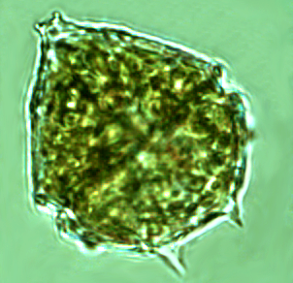
Phylum: Dinoflagellata
Class: Dinophyceae
Order: Peridiniales

Habitat: plankton, pelagial
Distinctive attributes: Co-occurs with Parvodinium elpatiewskyi
Organization: flagellated single cells
Color: golden-brown
Cell shape: prolate spheroid
Cell size: varies significantly over an annual cycle
Cell diameter (D): 21 - 30 μm, median: 25.6 μm (N=>2000)
Cell length: 27 – 36 μm, median: 31 μm (N=700)
Cell biovolume: 6300 - 17500 μm³, median: 10500 μm³.
Biovolume equation: V = 2.099 D^{2.623}

Morphological features:
Cells shape is of half sphere (hypotheca) + half cone (epitheca) of about the same diameter above it, with the cingulum traversing the cell where they connect (Plate 1). The apex of the epitheca has a “mouth” shape. Two to six spines extend from the hypotheca. The sulcus barely extends into the epitheca, it widens along the hypotheca where it does not reach the antapex. Red bodies often seen (Plate 1a-c). Resting cysts (not shown) are oval with a thick cell wall. Parvodinium cunningtonii is like P. elpatiewskyi in size and shape, and they tend to co-occur. See here our tips for distinguishing between these two species under the light microscope.

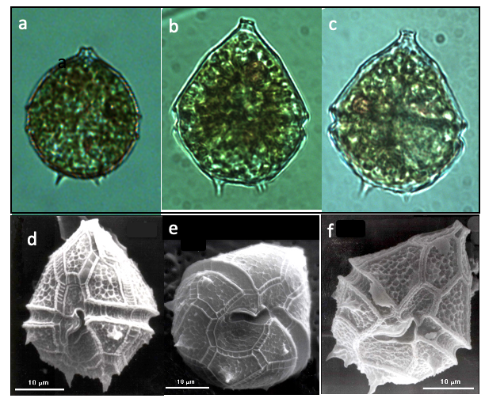
Plate 1. Light microscope (a-c) and SEM (d-f) photographs of Parvodinium cunningtonii, showing shape and typical small spines/horns extending from the hypotheca. The “mouth” shape at the top of the cell is diagnostic. Note red-brown stigma (eye spots) in a-c. Light microscope photos: Alla Alster; SEM photos: Barbara Hickel.
Ecology:
Parvodinium cunningtonii is one of the species always present in the water column, contributing to total phytoplankton biomass up to 20-30%. The species was less abundant before the mid 1990s, when Peridinium gatunense bloomed every year, but has become more abundant with the decline of Peridinium gatunense in recent years (Fig. 1). Parvodinium cunningtonii tends to co-occur with Ps elpatiewskyi (Figs. 1, 2).
Parvodinium cunningtonii abundance shows a typical annual cycle of population increase in March, peak in April and decline in May-June, with low abundances but continuous presence throughout the summer (Fig. 3). Cell size fluctuates seasonally, with largest size in winter, smallest in summer (Fig. 3). This feature is shared with several other Kinneret dinoflagellates.
Environmental conditions:
Parvodinium cunningtonii cell abundance > 20 mL⁻¹ occurred more frequently but not exclusively at Chloride concentration > 225 mg L⁻¹, conductivity > 1050 μS cm⁻¹, pH > 8.5, over the full range of alkalinities (90-140 mg CaCO₃ L⁻¹, dissolved oxygen > 10 mg L⁻¹, at a relatively narrow range of long-wave radiation (320-385 Watt m⁻²), but over the full range of short-wave radiation (100-350 Watt m⁻²) and water temperatures (14-30°C), when the lake was stratified. The high levels of dissolved oxygen during its high abundance are unusual (Fig. 4). These conditions are extremely similar to those under which Parvodinium elpatiewskyi is abundant and indeed the two species nearly always co-occur (Figs 1, 2).
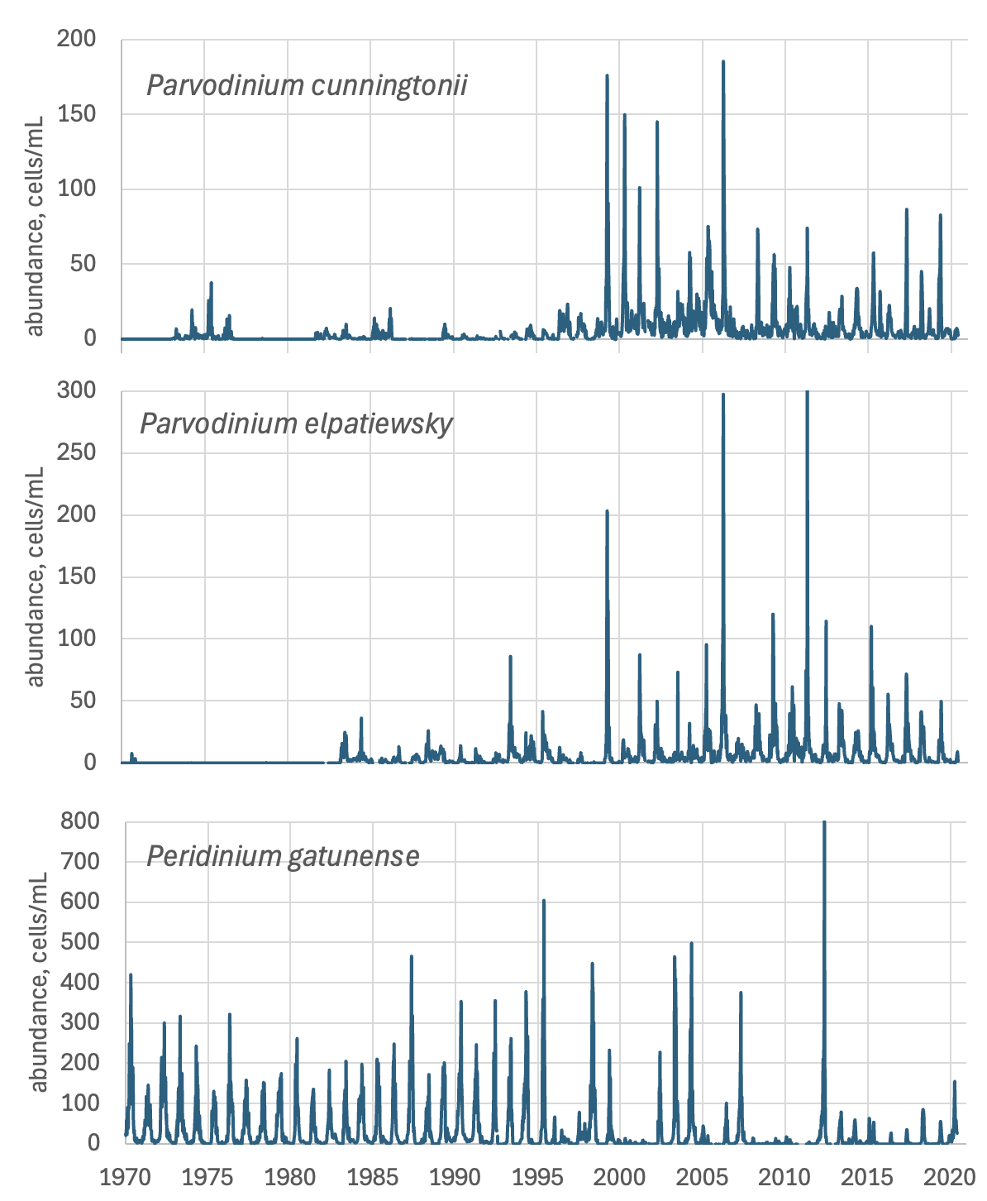
Figure 1. Time series of the abundance (cells/mL) of three dinoflagellates: Parvodinium cunningtonii, Parvodinium elpatiewskyi and Peridinium gatunense, showing that the two Parvodinium species tend to co-occur and that the abundance of both has greatly increased since the mid 1990s, when Peridinium gatunense no longer blooms each year.
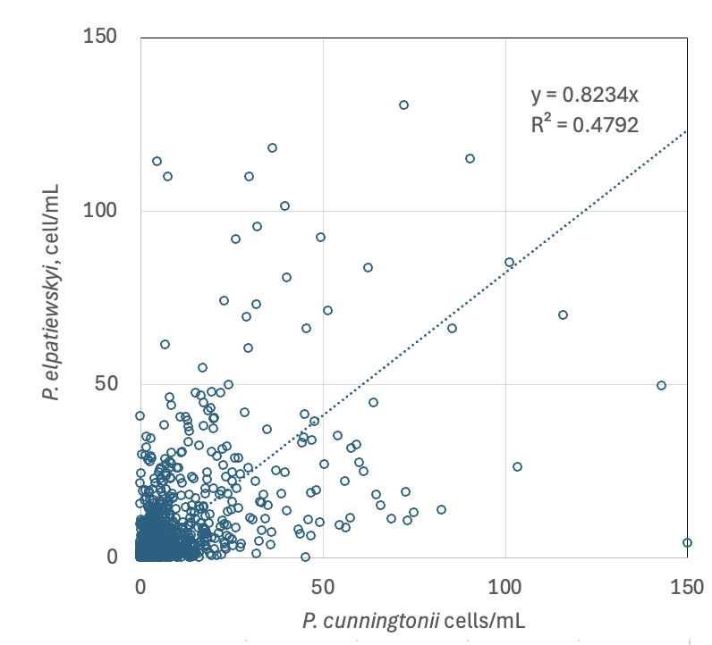
Figure 2. Regression of Parvodinium cunningtoni abundance (cells mL⁻¹) vs. Parvodinium elpatiewsky abundance.
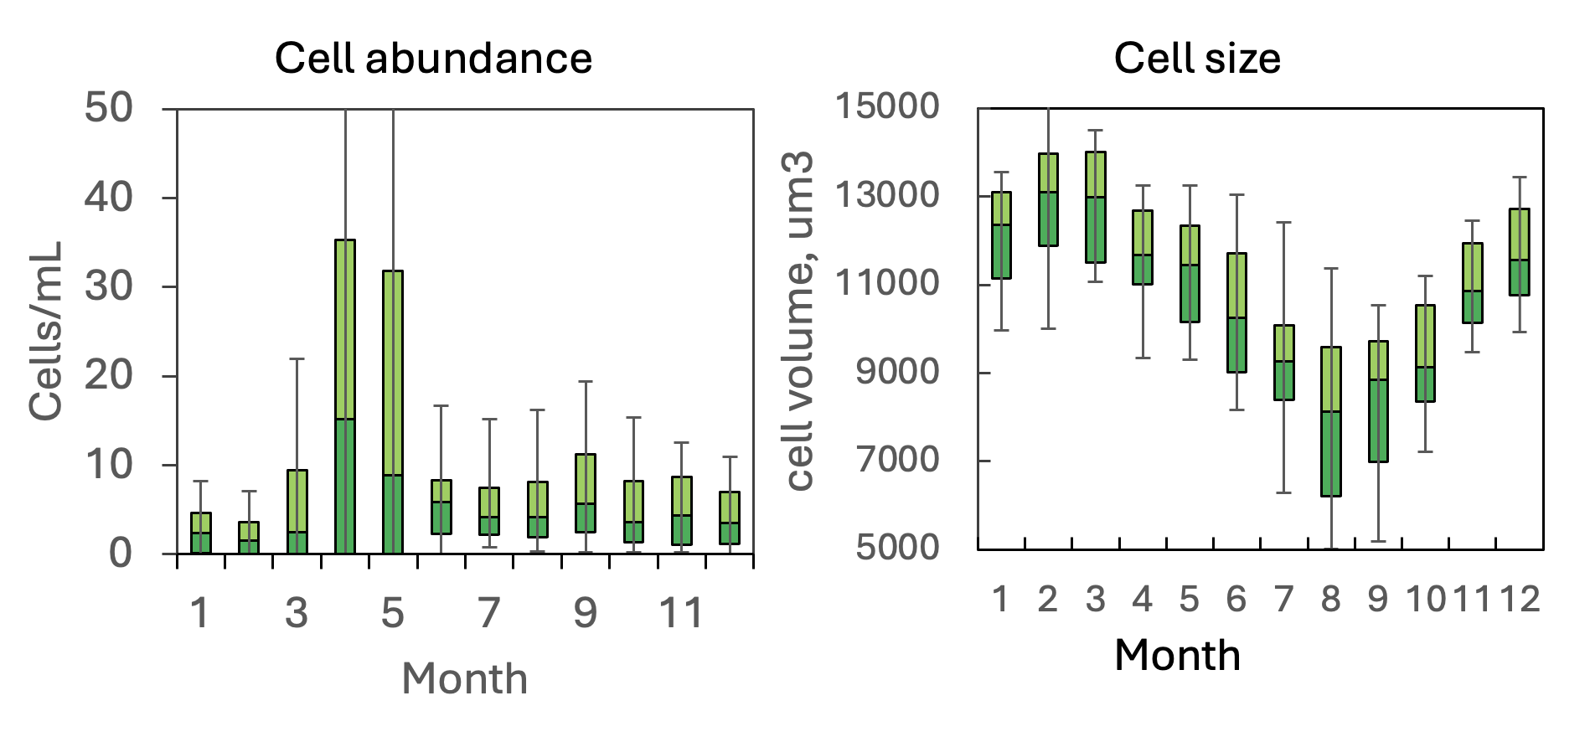
Figure 3. Parvodinium cunningtonii – The seasonal pattern of cell abundance and cell size, showing the characteristic spring peak abundance (left) and an annual cycle with larger cells in winter, smaller in summer (right) this species shares with several other Kinneret dinoflagellates.

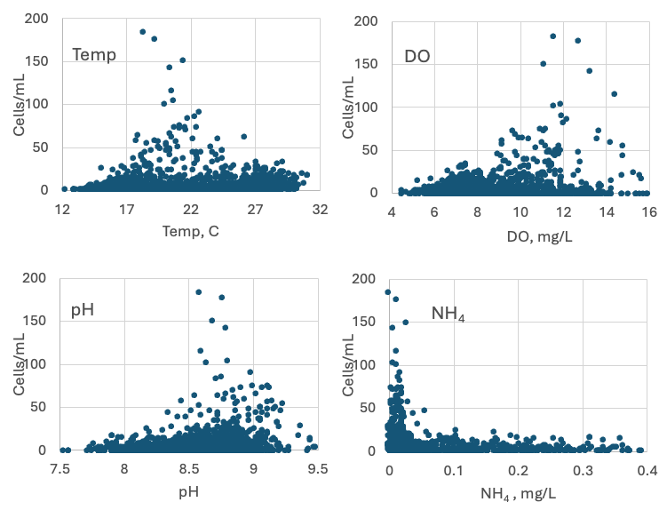
Figure 4. Parvodinium cunningtoni abundance (cells mL⁻¹) vs. environmental parameters recorded at the site and time of sampling.
Cite this record as:
Tamar Zohary, Alla Alster. 16 April 2026. Electronic publication. Israel Oceanographic & Limnological Research. [Date when last accessed].
Further reading:
Hansen G, Flaim G. 2007. Dinoflagellates of the Trentino Province, Italy. J Limnol. 66:107-141.
Pandeirada MS, Craveiro SC, Daugbjerg N, Moestrup Ø, Calado AJ. 2022. Ultrastructure and phylogeny of Parvodinium cunningtonii comb. nov. (syn. Peridiniopsis cunningtonii) and description of P. cunningtonii var. inerme var. nov. (Peridiniopsidaceae, Dinophyceae). Eur J Protistol. 86:125930.
Pollingher U, Hickel B. 1991. Dinoflagellate associations in a subtropical lake (Lake Kinneret, Israel). Arch Hydrobiol. 120:267-285.
Zohary T, Fishbein T, Shlichter M, Naselli-Flores L. 2017. Larger cell or colony size in winter, smaller in summer – a pattern shared by many species of Lake Kinneret phytoplankton. Inland Waters 7:200-209.

Peridiniopsis cunningtonii var. quinquecuspidata (Massart) Nygaard 1926
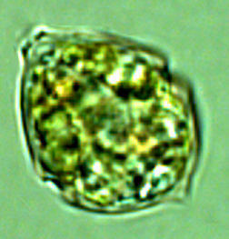
Phylum: Dinoflagellata
Class: Dinophyceae
Order: Peridiniales
Habitat: plankton, pelagial
Organization: flagellated single cells
Color: golden-brown
Cell shape: sphere
Cell Diameter: (D): 13 - 18 μm, median: 15.5 μm (N=450)
Cell biovolume: 17500 - 4300 μm³, median: 2900 μm³.
Biovolume equation: V = (4/3) π D³ (sphere)

Morphological features: This is a smaller variety of the species named today Parvodinium cunningtonii, with cell shape that is close to a sphere (Plate 1). It is common in the lake. It was named and counted as Peridiniopsis cunningtonii var. quinquecuspidata (Massart) Nygaard. Today, the variety is considered a species of its own, Peridiniopsis quinquecuspidata (Hansen and Flaim 2007) – but the organism they describe looks different to what we named Peridiniopsis cunningtonii var quinquecuspidata. As a result, we are uncertain about its correct taxonomic allocation and provide here no further data.
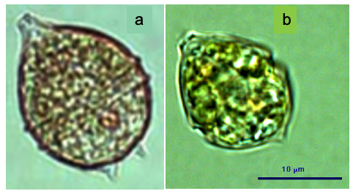
Plate 1. (a) Parvodinium cunningtonii; (b) The dinoflagellate we refer to as Peridiniopsis cunningtonii var quinquecuspidata. It looks like but smaller than P. cunningtonii. Photos: Alla Alster.
Cite this record as:
Tamar Zohary, Alla Alster. 16 April 2026. Electronic publication. Israel Oceanographic & Limnological Research. [Date when last accessed].

Parvodinium elpatiewskyi (Ostenfeld) Kretschmann et al 2019
Previous name used: Peridiniopsis elpatiewskyi (Ostenfeld) Bourrelly 1968

Phylum: Dinoflagellata
Class: Dinophyceae
Order: Peridiniales

Habitat: plankton, pelagial
Distinctive attributes: Co-occurs with P. cunningtonii
Organization: flagellated single cells
Color: yellow to golden-brown
Cell shape: prolate spheroid
Diameter (D): 21 - 30 μm, median: 26 μm (N=>2000)
Length (L): 28 – 37 μm, median: 32.5 μm (N=700)
Cell biovolume: 6600 - 17500 μm³, median: 11500 μm³.
Biovolume equation: V, μm³ = 1.2514 D^{2.793} (regression eqn. based on >500 measurements of both D and L with V computed for a prolate spheroid).

Morphological features: Cells are pentangular (having 5 sides) or ovoid in shape and slightly flattened dorsi-ventrally. The epitheca is conical, with a “mouth” shaped apex (uppermost end) and is larger than the hypotheca, which is rounded but excavated on the antapex (base, opposite to the apex). The cingulum encircles the cell; the sulcus widens along the hypotheca. Several spines or teeth-like projections are present on the hypotheca, typically some of them are lined up as in a brush (Plate 1). The chloroplasts are numerous and discoid. A red body is occasionally seen (Plate 1). SEM shows that the plates are concave and ornamented by rows of fine punctae, and that the sulcus extends all the way to the concave base of the hypotheca. The resting cysts (not shown) are somewhat oval with a thick cell wall, 36 μm x 28 μm. Parvodinium elpatiewskyi is similar to P. cunningtonii in size and shape, and they tend to co-occur. See here our tips for distinguishing between these two species under the light microscope.
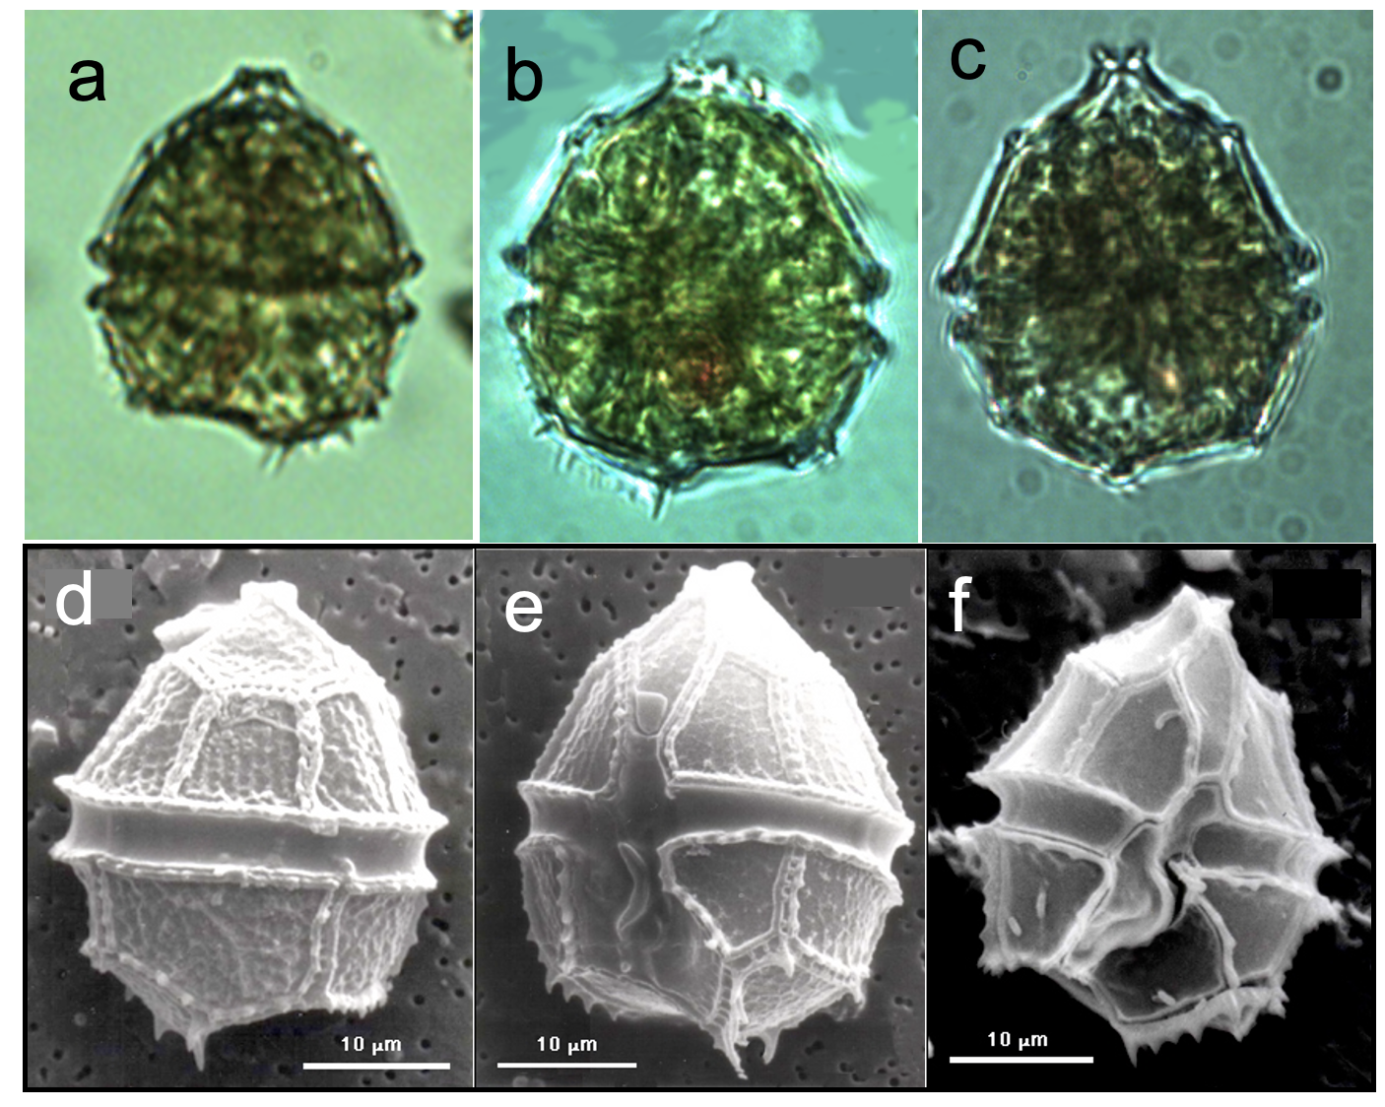
Plate 1: Parvodinium elpatiewskyi from Lake Kinneret. The light microscope photos (a-c) show concave base, with a line of horns on one side, distinct cingulum, red bodies, rounded epitheca with a mouth-shaped apex. The SEM photos (d-f) show that the plates are concave, ornamented by rows of fine punctae, and that the sulcus extends all the way to the concave base of the hypotheca. Light microscope photos: Alla Alster; SEM photos: Barbara Hickel.
Ecology: Parvodinium elpatiewskyi is one of the common algal species in the Kinneret plankton, present in the water at all times of the year. In the absence of Peridinium gatunense in recent years, Parvodinium elpatiewskyi seems to be more abundant than in Peridinium bloom years, although 1999 was an exception (Fig. 1). It always occurs with a second species of the same genus - Parvodinium cunningtonii (Figs. 1, 2). Its abundance has a typical annual cycle with a peak between April and June (Fig. 3). Cell size also fluctuates seasonally, being smaller in summer, larger in winter (Fig. 3). Peak cell size (February-March) precedes peak abundance by 2-3 months. These seasonal cycles are shared with Parvodinium cunningtonii and Peridiniopsis borgei. The multiannual average contribution of this dinoflagellate to total phytoplankton biomass is 3%. Its maximum biomass ever recorded was 53 g m⁻² - 41% of total biomass, in April 2006, a “no-Peridinium” year.
Environmental conditions: Parvodinium elpatiewskyi > 5 g m⁻² or > 25 cells mL⁻¹ occurred more frequently but not exclusively at calcium concentrations > 45 mg L⁻¹, pH > 8.5, dissolved oxygen > 10 mg L⁻¹, showing greater abundance at low NH4 and TDP, wide range of DON (Fig. 4). Furthermore (not shown), the higher biomasses usually occur at chloride > 230 mg L⁻¹, conductivity > 1050 μS cm⁻¹, alkalinity > 115 mg CaCO₃ L⁻¹, at a relatively narrow range of long wave radiation (300-370 Watt m⁻²), but over the full range of short-wave radiation (100-350 Watt m⁻²) and water temperatures (14-30°C), when the lake is stratified. Cell size declines with increasing temperature, especially at temperatures below 23°C, and increases with calcium and alkalinity (Fig. 5).
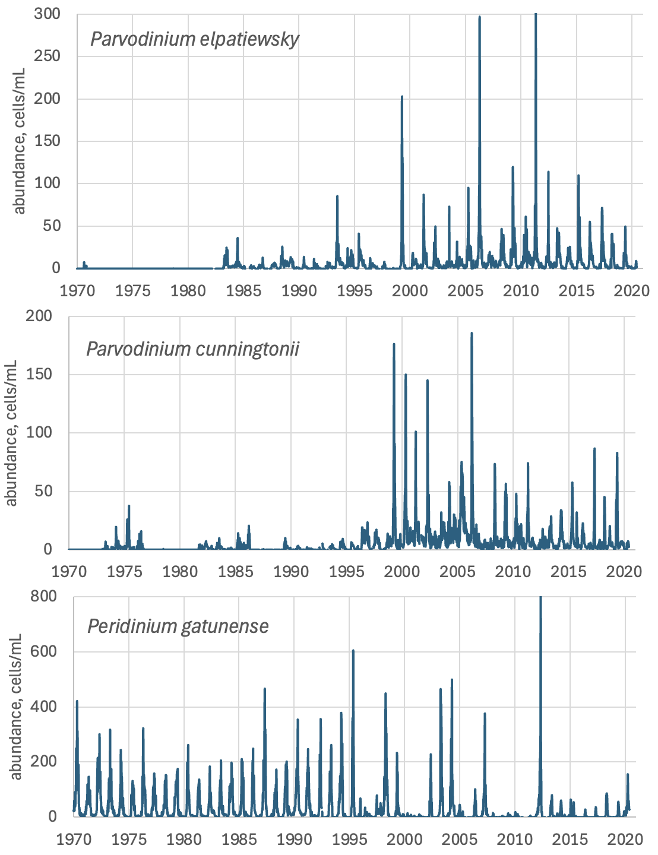
Figure 1. Time series of the abundance (cells/mL) of three dinoflagellates: Parvodinium elpatiewskyi, Parvodinium cunningtonii, and Peridinium gatunense, showing that the two Parvodinium species tend to co-occur and that the abundance of both has greatly increased since the mid 1990s, when Peridinium gatunense no longer blooms each year.
Figure 2. Regression of Parvodinium cunningtoni abundance vs. Parvodinium elpatiewsky abundance.
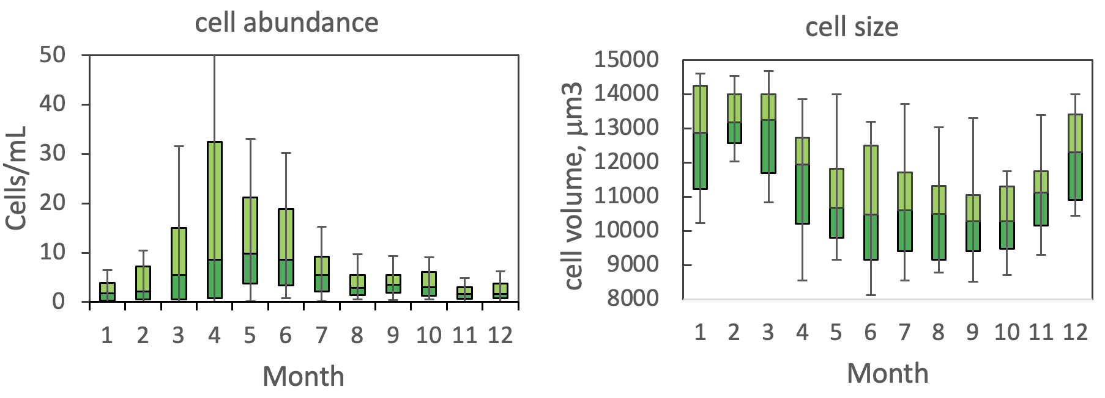
Figure 3. The seasonal pattern of water column cell abundance (left) and volume per cell (right) of Parvodinium elpatiewskyi.
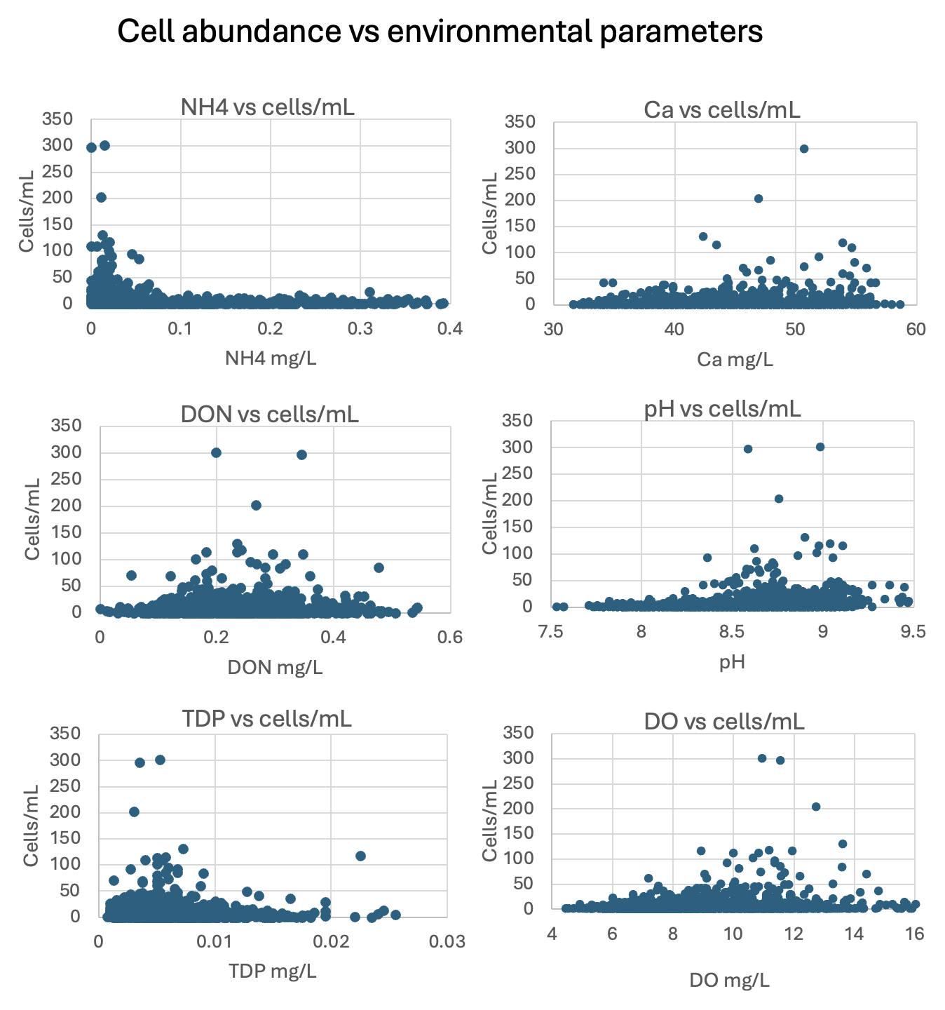
Figure 4. P. elpatiewskyi abundance (cells mL⁻¹) vs. selected environmental parameters recorded at the site and time of sampling, showing greater abundance at: low NH₄ and TDP; wide range of DON; and higher pH, DO and calcium levels.
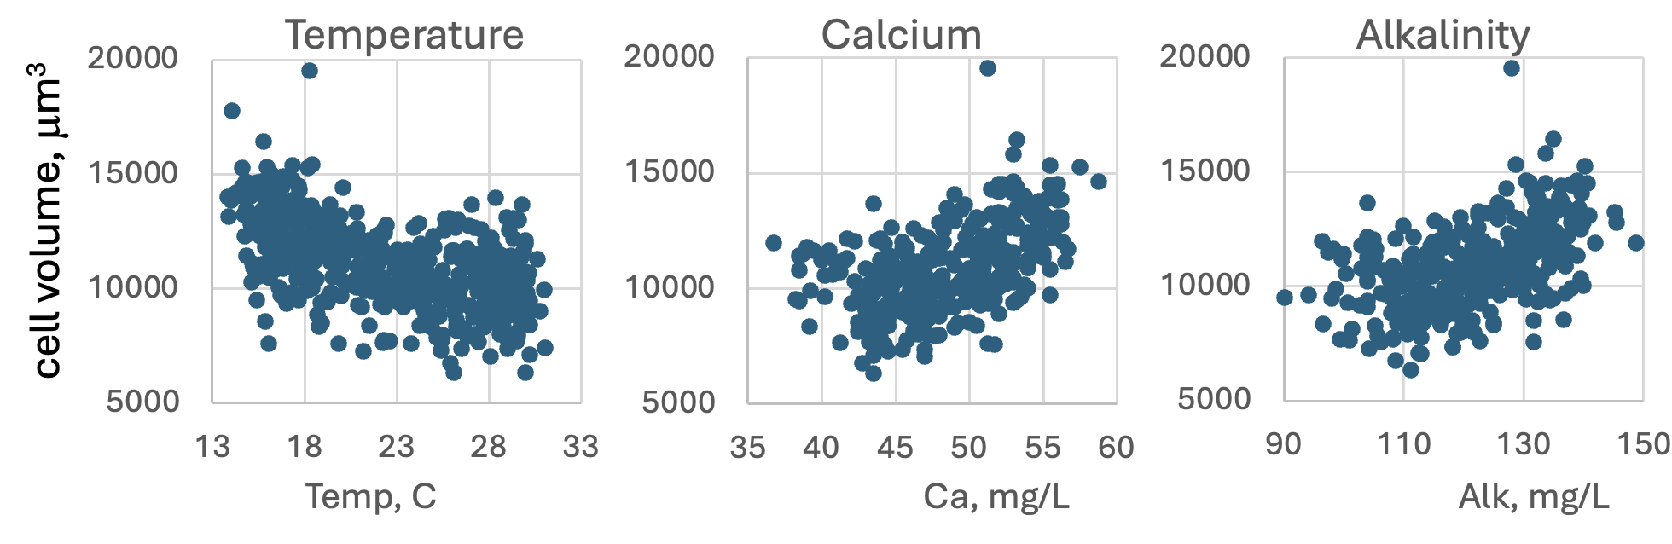
Figure 5. P. elpatiewskyi cell size (μm³) vs. environmental parameters recorded at the site and time of sampling. Data for 2006-2020.
Cite this record as:
Tamar Zohary, Alla Alster. 16 April 2026. Electronic publication. Israel Oceanographic & Limnological Research. [Date when last accessed].
Further reading:
Hansen G, Flaim G (2007) Dinoflagellates of the Trentino Province, Italy. J Limnol. 66:107-141.
Pollingher U, Hickel B (1991) Dinoflagellate associations in a subtropical lake (Lake Kinneret, Israel). Arch Hydrobiol. 120:267-285.
Zohary T, Fishbein T, Shlichter M, Naselli-Flores L (2017) Larger cell or colony size in winter, smaller in summer – a pattern shared by many species of Lake Kinneret phytoplankton. Inland Waters 7:200-209.

Durinskia oculata (Stein) Gert Hansen et Flaim 2007
Previous name used: Peridiniopsis oculatum (Stein) Bourrelly 1968
(Previously referred to as Glenodinium oculatum Stein 1883)
Phylum: Dinoflagellata
Class: Dinophyceae
Order: Peridiniales
Habitat: plankton, mostly littoral
Organization: single cells
Color: yellow to golden-brown
Cell shape: ovoid or spherical
Cell Diameter (D): 17 - 26 μm, median: 22 μm (N=700)
Cell biovolume: 2600 - 9500 μm³, median: 5300 μm³.
Biovolume equation: V, μm³ = (4/3) π (D/2)^{3.} (sphere equation)

Morphological features: Cells are ovoid or spherical and slightly flattened dorsiventrally. The epitheca and hypotheca are both half-sphere shaped, making together a sphere. The cingulum surrounds the cell at its middle (Plates 1a,b, 2). The sulcus is wide and does not reach the antapex. Chloroplasts are numerous, disc or club shaped and parietal. A stigma is present. Vegetative cells are often embedded in mucilage. Thecae are barely seen on live cells therefore it was initially considered to be Glenodinium, a naked dinoflagellate, but the theca is evident after the cell sheds it (Plate 1c, 4).
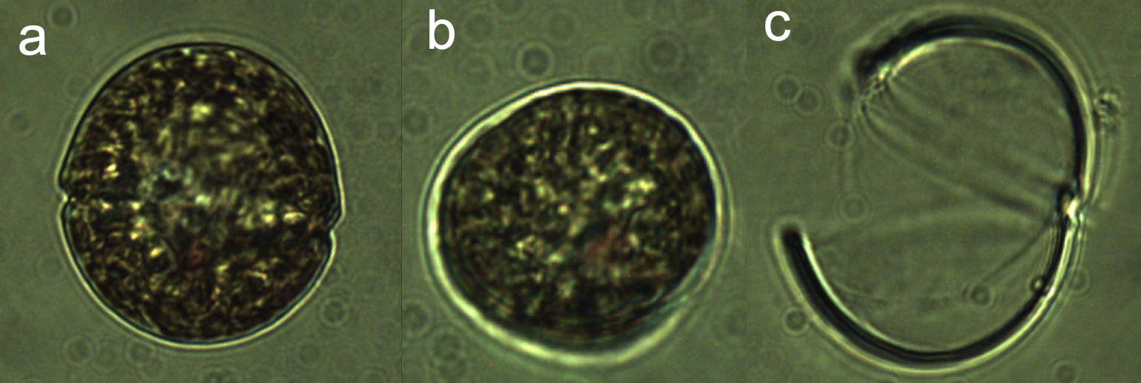
Plate 1. Durinskia oculata, (a) vegetative cell, (b) protoplast that has emerged out of its theca, (c) the empty thecae. Photos: Alla Alster.
Plate 1. Six cells of Durinskia oculata. A non-pigmented parasitic chytrid is attached to the rightmost cell. Photo: Alla Alster.

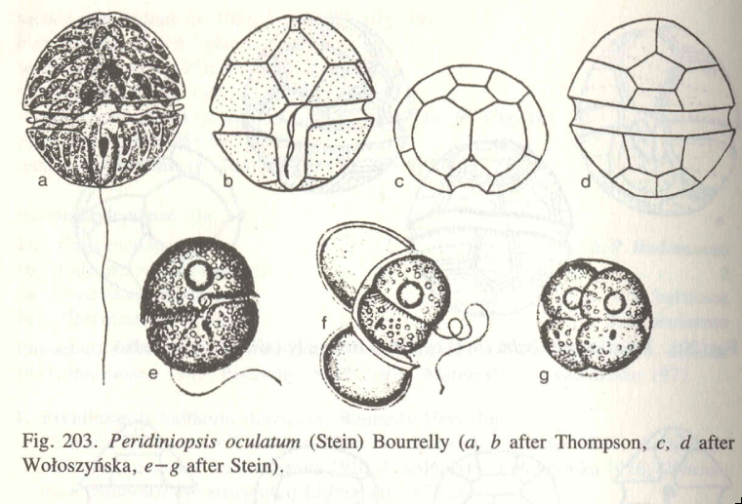
Plate 4. Hand drawings of Durinskia oculata from Popovsky and Pfiester 1990.
Ecology: Durinskia oculata is rare in the pelagic water, it appeared in our samples in 1973-1975, then disappeared for many years, to re-appear for a short time in May 2000 and then again in June 2005. It appears more often in littoral samples. Little is known about this species.
Cite this record as:
Tamar Zohary, Alla Alster. 16 April 2026. Electronic publication. Israel Oceanographic & Limnological Research. [Date when last accessed].
Further Reading:
Popovsky J, Pfiester LA. 1990. Süßwasserflora von Mitteleuropa. Dinophyceae (Dinoflagellida). Vol. 6 pp. 1-272. Jena & Stuttgart: Gustav Fischer.

Glochidinium penardiforme (Lemmermann) Boltovskoy 2000
Previous name used: Peridiniopsis penardiforme (Lindemann) Bourrelly 1968
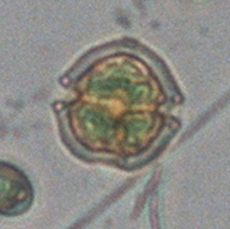
Phylum: Dinoflagellata
Class: Dinophyceae
Order: Peridiniales
Habitat: plankton, littoral
Organization: flagellated single cells
Color: golden-brown to greyish
Cell shape: ovoid or prolate spheroid
Diameter (D): 17 - 24 μm, median: 21 μm (N=160)
Length (L): 20 – 27.5 μm, median: 23 μm (N=160)
Cell biovolume: 3050 - 8200 μm³, median: 5450 μm³.
Biovolume equation: V = (4/3)π L (D/2)² (prolate spheroid)

Morphological features: Cells are pentangular (having 5 sides) and flattened dorsi-ventrally (Plates 1, 2, 3). The epitheca is conical and apiculate; the hypotheca is excavated at the antapex (its bottom side, Plates 2,3), both thecae are equal in size. The wide, deep cingulum encircles the cell, the sulcus is broad, deep and reaches the antapex. It produces a marked concavity in the antapical profile. Chloroplasts are present. The protoplasm may have a dark granular appearance, such that it is grayish in color. Numerous highly refractive granules may or may not be present in the cell periphery (Plates 1, 2).

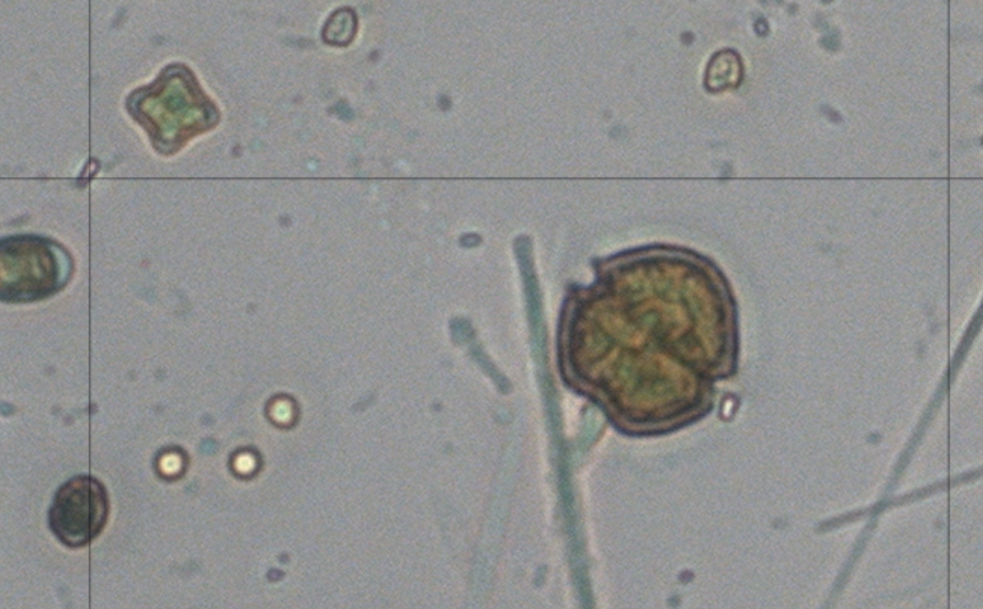
Plate 1. Glochidinium penardiforme, light microscopy. Photo: Alla Alster.
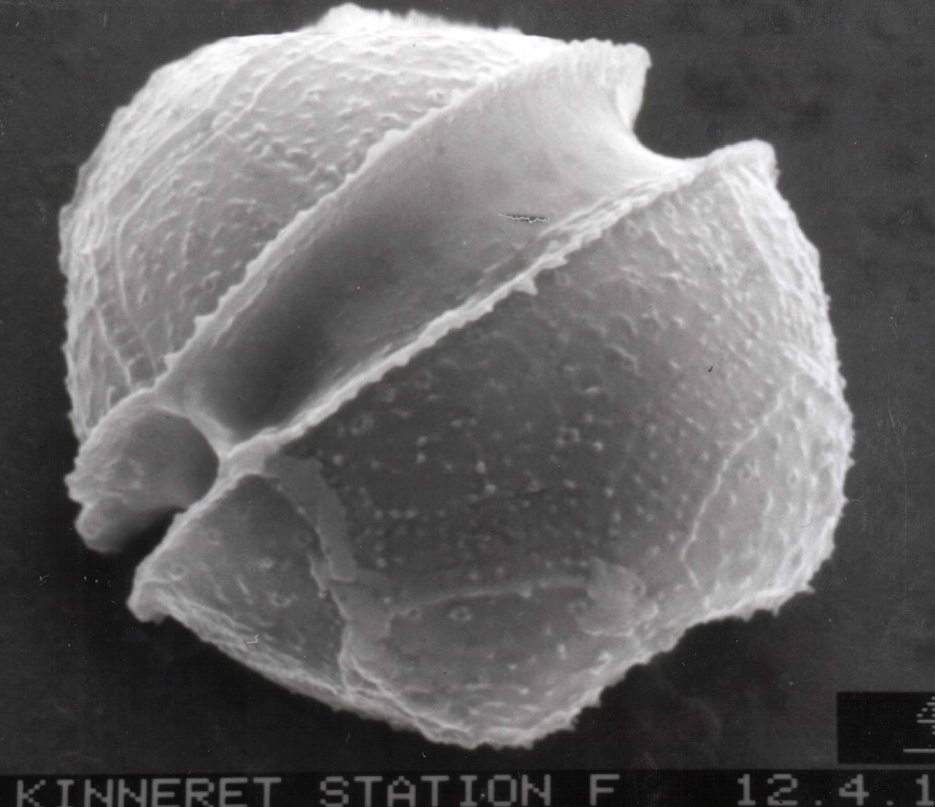
Plate 2. Glochidinium penardiforme, SEM photo by Barbara Hickel.
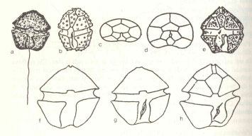
Plate 3. Glochidinium penardiforme. Hand drawings from Popovsky and Pfeister 1991.
Ecology: Glochidinium penardiforme is another relatively rare species in Lake Kinneret. It occurred quite regularly between 1983 and 1997, then disappeared from the plankton for 10 years to re-appear in 2008 (Fig. 1). Its mean water column abundance never exceeded 20 cells mL⁻¹. Little is known about this species.
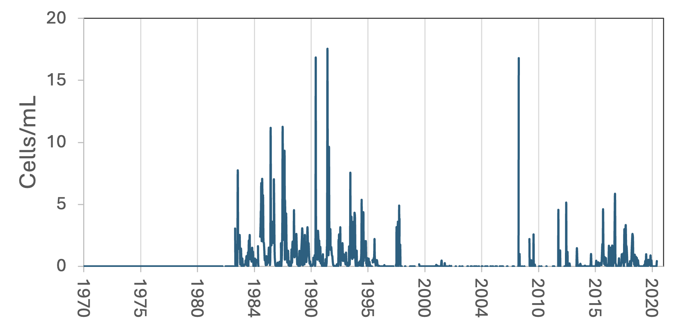
Figure 1. Time series of Glochidinium penardiforme abundance (cells mL⁻¹), Lake Kinneret, 1970-2020. Prior to 1983 the species wasn’t counted.
Cite this record as:
Tamar Zohary, Alla Alster. 16 April 2026. Electronic publication. Israel Oceanographic & Limnological Research. [Date when last accessed].

Naiadinium polonicum (Woloszynska) Carty 2014
Previous name used: Peridiniopsis polonicum (Woloszynska) Bourrelly 1968; Glenodinium Gymnodinium Penard 1891
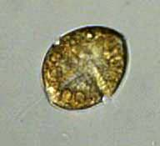
Phylum: Dinoflagellata
Class: Dinophyceae
Order: Thoracosphaerales

Habitat: plankton, littoral
Distinctive attributes: convex-concave shape, seen when it circles around itself while swimming
Organization: flagellated single cells
Color: yellow to golden-brown
Cell shape: a prolate spheroid that was punched in its “belly” so that from dorsal view it is concave
Diameter (D): 29-36 μm, median: 32 μm (N=32)
Length (L): 32-42 μm, median: 38 μm (N=32)
Cell biovolume: 7,000-14,000 μm³, median: 10,000 μm³
Biovolume equation: V = ((4/3)π L (D/2)²)/2 (half the volume of a prolate spheroid)

Morphological features: A medium-sized thecate dinoflagellate. The flagellated cells are oval, with the ventral side pressed in towards the other side as if it received a punch. As a result, the cell perimeter is convex when viewed from one side but concave when viewed from another (Plate 1). This concave/convex form is easily seen on a live, swimming cell: as it turns about its longitudinal axis its profile changes dramatically (Plate 1e). This feature is the most obvious for identifying this species. An additional diagnostic feature is the smooth and rounded cell shape (Plate 1). The epitheca is helmet-shaped and pointed and is approximately the same size as the broadly rounded hypotheca. The chloroplasts are small and discoid or ribbon shaped. A stigma (eyespot) may be present. Resting cysts are spherical with their thick cell wall covered by dense hairlike projections (not shown).
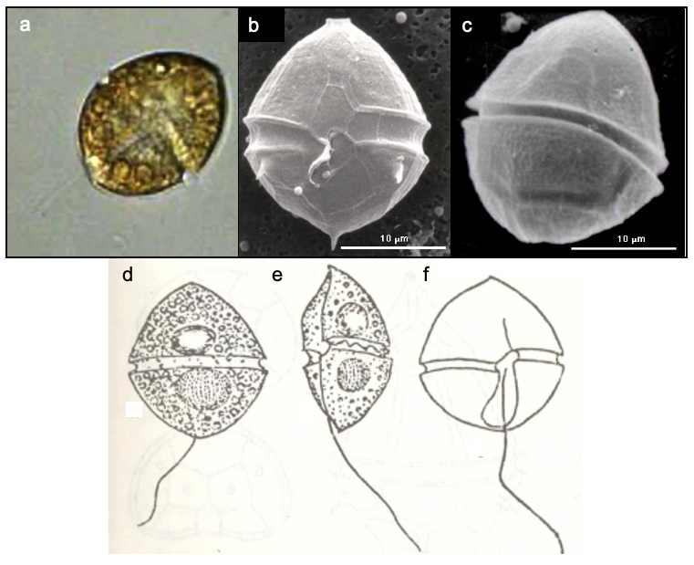
Plate 1. Naiadinium (previously Peridiniopsis) polonicum. Light (a) and SEM (b, c) photographs, showing the general shape, cingulum and thecal plates. (a, b) ventral view; (c) dorsal view. (d-f): hand drawings showing the cells with their longitudinal flagellum, helmet-shaped epi-theca, round-based hypotheca, eyespot (stigma) and nucleus. The short and wide sulcus reaches the antapex (f). When viewed from the side (e) the convex-concave shape is evident. Light microscope photos: Alla Alster. SEM photos: Barbara Hickel. Hand drawings: from Popovsky and Pfeister 1990, after Penard 1891.

Ecology: Naiadinium polonicum occurs in the Kinneret plankton but in low numbers, usually < 5 cells/mL⁻¹ (Fig. 1). It is more abundant in shore samples than in pelagic waters. Its peak abundance is in April; it is absent in the water column during summer-fall (Fig. 2).
Environmental conditions: Higher abundance of N. polonicum is associated with the full range of Alkalinity, Ca, dissolved oxygen (not shown) and water temperatures, low concentrations of DIN (nitrate, ammonium) but intermediate concentrations of DON (Fig. 3). It tends to be more abundant at the lower salinities experienced in Lake Kinneret (Chloride < 250 mg/L) and at pH levels > 8.4 (Fig. 3).

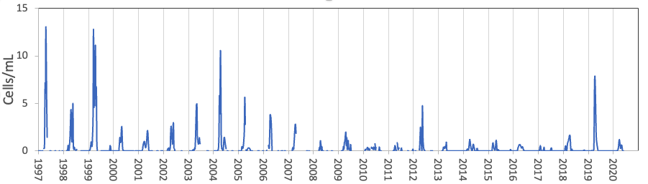
Figure 1. Time series of Naiadinium polonicum cell abundance (mean epilimnion concentration) in Lake Kinneret, 1997-2020.
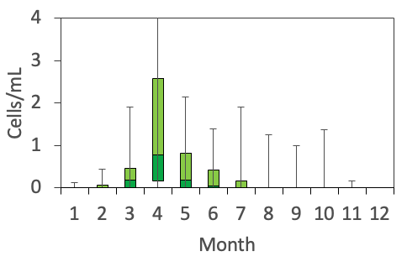
Figure 2. The seasonal pattern of Naiadinium polonicum cell abundance. Based on data for 1970-2020.
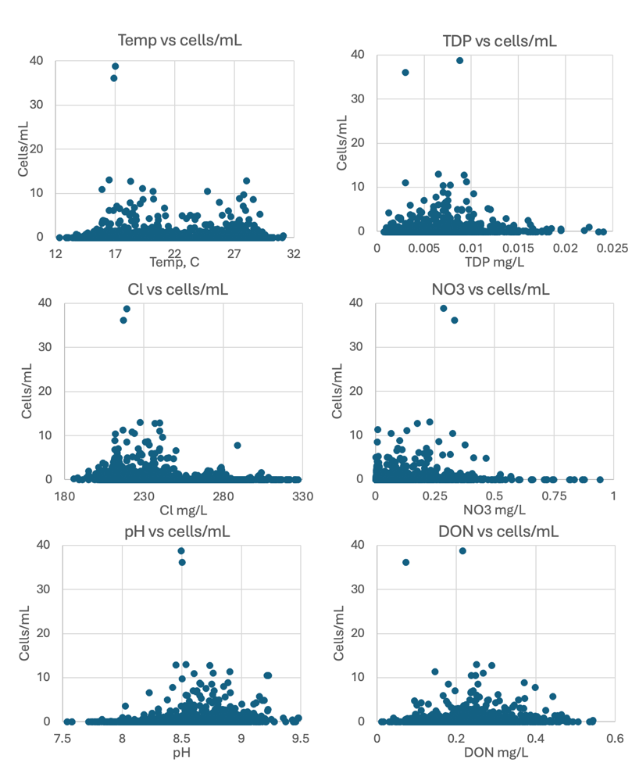
Figure 3. Naiadinium polonicum vs. selected environmental parameters from Lake Kinneret. Based on data for 1970-2020.
Cite this record as:
Tamar Zohary, Alla Alster. 16 April 2026. Electronic publication. Israel Oceanographic & Limnological Research. [Date when last accessed].
Further reading:
Hansen G, Flaim G. 2007. Dinoflagellates of the Trentino Province, Italy. J Limnol. 66:107-141.
Penard E. 1891. Les Peridiniacees du Lac Leman. Bull. Trav. Soc. Bot. Geneve 6: 1-63.
Pollingher U, Hickel B. 1991. Dinoflagellate associations in a subtropical lake (Lake Kinneret, Israel). Arch. Hydrobiol. 120: 267-285.
Popovsky, J. & Pfiester, L.A. 1990. Süßwasserflora von Mitteleuropa. Dinophyceae (Dinoflagellida). Vol. 6 pp. 1-272. Jena & Stuttgart: Gustav Fischer.

